ANNOTATED VERSION [Yellow & Red]: Comments/ highlights by Ed Friedman 2/5/04

Maine Department of Environmental protection
Dioxin Monitoring Program
Review Panel Report
January 28, 2004

S. Marshall Adams, Ph.D.
Environmental Sciences Division
Oak Ridge National Laboratory
Oak Ridge, TN 37831-6036

William Halteman, Ph.D.
Department of Mathematics
The University of Maine
Orono, ME 0446

Carolyn Mattingly, Ph.D.
Mount Desert Island Biological Laboratory
PO Box 35, Old Bar Harbor Rd
Salisbury Cove, ME 04672

David Page, Ph.D.
Department of Chemistry
Bowdoin College
Brunswick, ME 04011

Table of Contents

Section Page
Executive Summary 3
Introduction 4
Sensitivity of A/B Test 5
Percent Lipid Data 6
Fish Tissue Chemistry Data 6
Specificity 6
Variability 7
Life History Attributes of Test Species 7
Variability in Percent Lipid Values 7
Surrogates to Fish as Sampling Methods 8
Overall Validity 11
Use of multiple tests (preponderance of evidence) in A/B comparisons 11
General Concept of Use 11
Application to the Dioxin A/B Tests 11
Proposed Statistical Approach to A/B testing 13
References 15

Figures Page
Figure 1. Sampling site schematic map 5

Tables Page
Table 1. Mean SPMD 2003 Results Data as ng/SPMD 8
Table 2. Experimental design considerations for A/B Test 9
Table 3. Above/Below Test: Comparison 10
Table 4. A/B tests: Features of Test Organisms/Devices 12

Appendices Page
Appendix 1: Summary Comparisons of 2003 Data 16
Appendix 2: 2003 Mussel data analysis 31
Appendix 3: Dioxin congener distributions for various sources 35
Appendix 4: Analysis of 2001 dioxin lipid data 38
Appendix 5: Statistical Calculations 42

Executive Summary

The Dioxin Monitoring Program (DMP) review panel was established to comment on the validity of the Above/Below (A/B) approach to determining compliance with dioxin discharge regulations, to provide an interpretation of the 2003 DMP data and to make recommendations on the development and application of the A/B test. The review panel considered monitoring data from prior years as well as 2003 data.
The consensus of the panel is that the A/B test is a valid way to detect dioxin release from a point source assuming an appropriate study design and accurate and precise chemical data, something yet to be achieved or at least verified and to increase in difficulty as contaminant levels continue to decline but that some adjustments are recommended in various aspects of the test. The panel’s conclusion, based on a review and assessment of the data, is that an MSD of 10% is not achievable with both errors (alpha/type I and beta/type II) set at 0.05, given a reasonable sample size. To ensure that all tests are realistic within a statistical framework and protective of public health, the panel recommends that the type I and II errors, that is the confidence levels, both be 90% (alpha = 0.10 and beta = 0.10) and that the sample size for fish at each site consist of 15 individuals.
Key recommendations and conclusions of the panel can be summarized as follows:
- In performing A/B tests, sums of dioxin congeners should be used in A/B tests to minimize the effects of non-detects in individual analytes. Only those congeners relevant to pulp and paper sources should be included in these calculations (Appendix 3; 2,3,78-tetrachlorodibenzo-p-dioxin [TCDD], 2,3,7,8-tetrachlorodibenzofuran [TCDF] and possibly 1,2,3,7,8 PeCDD and 1,2,3,7,8 PeCDF). I have yet to be shown the methodology from which this fingerprint conclusion is drawn. It is not documented in the EPA dioxin reassessment that is cited later in this report. Because fish seem to preferentially accumulate at least 2378-TCDD and have been the most commonly studied monitor over the years I have a very strong suspicion that the “fingerprint congeners” are actually a reflection of fish uptake not mill output.
- Three independent experimental systems should be used for A/B testing including Small mouth bass (SMB), White Suckers (WHS) and caged mussels. Caged mussels should be used as a surrogate in combination with the fish to allow a preponderance of evidence (POE) approach for conducting the A/B tests. Mussels have the advantage of sampling recently released dioxins in the water that are present during the period of deployment and provide a valuable supplement to fish data which can reflect uptake from current or past dioxin discharges or both. The law addresses only current discharges.
- A POE statistical approach should be used as the most sensitive possible test, where 15 individual fish are sampled at each site and α = 0.10 and β = 0.10 are used for each test. A 2 out of 3 POE criterion for compliance based on A/B comparisons of sums of tissue concentrations of 2,3,7,8-tetrachlorodibenzo-p-dioxin (TCDD) and 2,3,7,8-tetrachlorodibenzofuran (TCDF) in SMB, WHS and caged mussels provides an overall confidence level greater than that mandated by regulations (ie, > 95%).
- DEP should continue to pursue a rigorous QA/QC program to produce dioxin tissue data and percent lipid data that are precise and accurate and to seek to lower method detection limits for dioxin congeners of interest.

Introduction
The Maine Department of Environmental Protection (DEP) on March 31, 2003 reported to the Legislature the development of an Above/Below (A/B) dioxin source monitoring test using bass filets and whole suckers that can detect only relatively large differences above and below pulp and paper mills. It is the intention of DEP to apply the A/B test to data collected in 2003. The Dioxin Monitoring Program (DMP) review panel was set up to comment on the validity of this approach, to provide an interpretation of the 2003 data and to make recommendations on the development and application of the A/B test.
The DMP review panel was asked to consider some specific issues, keeping in mind that Maine statute states that there shall be "no discharge of dioxin." Note that the statute does not discriminate between congeners [i.e. not just 2378-TCDD & TCDF] and also pertains to current discharge not historical , thus a monitor must reasonably be expected to discern between the two. These are basic issues to be resolved long before entering the realm of statistical intricacies. They include:
“• Because of year-to-year variability in sensitivity (lowest minimum significant difference), we intend to use both species of fish, bass and suckers, while others recommend use of only bass. Does use of two species provide more specific information?” ¹
“• We intend to use 3 measures of dioxin, namely 2378-TCDD, 2378-TCDF, and TEQ (Dioxin Toxic Equivalents-DTE to us in Maine) while others favor only one endpoint, TEQ. Which is more appropriate?” ¹
“• Is DEP's use of zero for non-detects appropriate for comparisons between above and below? Others suggest use of one-half the detection limit for non-detects.” ¹
“• Both DEP and the Maine Pulp and Paper Association's consultant agree on the use of a t-test if the assumptions of equal variances and normal distribution are met, and use of the non-parametric MannWhitney test otherwise. Is there a better test we should use?” ¹
“• Are either or both of the surrogates, SPMDs or caged mussels, better than the fish test? Do either or both add value to the fish test? Should we use more than one test? Should we use EPA's principle of Independent Applicability, where all tests count and must pass, or a weight of evidence approach, assuming all tests are equally sensitive and valid?”¹
The review panel was asked to review, comment and make recommendations on the following relating to the Dioxin A/B test:
1. Sensitivity
2. Specificity
3. Variability
4. Overall Validity of A/B Test
This report is structured according to these 4 elements. The review panel considered monitoring data from prior years as well as 2003 data. These data included dioxin congener concentrations from SMB and WHS from the sites shown in Figure 1 and caged mussels from studies conducted in 2000 and in 2003 and semi-permeable membrane devices (SPMD) deployed in 2003.

Figure 1. Schematic map of sampling sites on the three rivers used by DEP for the A/B testing.

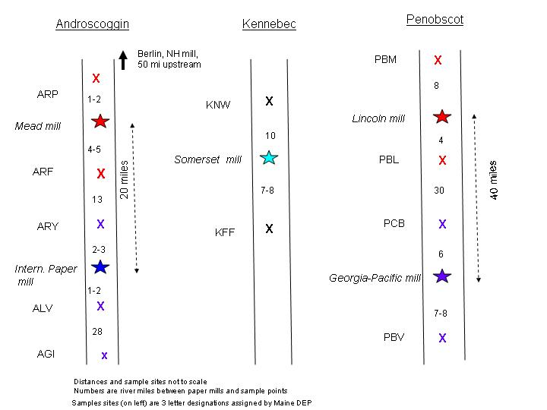

Sensitivity of A/B Test
The sensitivity of the A/B test depends strongly on the precision and accuracy of the analytical data. As the rivers become cleaner due to dioxin mitigation, measuring differences between smaller A/B means will become increasingly difficult because dioxin analyte concentrations will be less than current method detection limits. This will require increased precision and accuracy of the analytical data with lower detection limits. An important consideration is the relevance of individual dioxin congeners and determining which are appropriate to measure in the A/B comparisons. Different dioxin sources will produce different congener distributions (Appendix 3). Environmental samples associated with pulp and paper sources, including those using chlorine dioxide, are dominated by the 2,3,7,8-tetrachlorodibenzo-p-dioxin (TCDD) and 2,3,7,8-tetrachlorodibenzofuran (TCDF) congeners (Macdonald et al. 1998). Among dioxin congeners, TCDD and 1,2,3,7,8-pentachlorodibenzodioxin (PeCDD) are the most toxic (Van den Berg, et al. 1998) and may therefore be of greater interest from a regulatory perspective. Other congeners commonly found in environmental samples from a variety of sources include the octachloro- and heptachloro-dibenzo dioxins which have toxicities that are 100 – 10,000 times lower than the 2,3,7,8 TCDD and 1,2,3,7,8-PeCDD congeners (Van den Berg, et al. 1998). Furthermore, because congeners like OCDD are ubiquitous and can be present at high levels, their inclusion may mask a TCDD signal and make the A/B test less sensitive. A TEQ (ND=0) approach would also be appropriate, because the OCDD congener would have a miniscule weight in determining the TEQ value. Adopting a TEQ (ND=0) or an approach that includes the specific congeners that are most relevant to the current putative source would provide the most sensitive A/B test.

Fish Tissue Chemistry Data
The 2003 chemistry data are generally more precise than data produced prior to this time. Currently, method detection limits for the dioxin congeners of most concern from pulp and paper sources, 2,3,7,8-tetrachlorodibenzo-p-dioxin (TCDD) and 2,3,7,8-tetrachlorodibenzofuran (TCDF), are 0.1ppt (parts per trillion). The QA/QC procedures that include matrix spikes are generally reasonable for these types of analyses. While there are outliers, the scatter in the data is smaller than in previous years. The standard deviations for the means (see Table 1,2 and 3 in Appendix 1) of the total TCDD/TCDF (defined as sum of 2,3,7,8-TCDF. 1,2,3,7,8-PeCDF, 2,3,7,8-TCDD and 1,2,3,7,8-PeCDD) range from 38% of the mean to 242% of the mean with a median value of 64%. There remains a problem with the t=0 mussel chemistry data, where the 2 laboratories involved had poor agreement in an intercalibration exercise.
Percent Lipid Data.
There is concern that the percent lipid data are neither accurate nor precise. For example, the 2003 percent lipid values for WHS range from 0.49% to 12.7% and for both fish species there is not an increasing relationship between percent lipid and fish size indicating problems in the methodology for lipid analysis. If A/B comparisons are to be made on a lipid normalized basis, then steps should be taken to ensure that the percent lipid data are of comparable quality to the dioxin analyte data. Appendix 4 discusses the limitations of the percent lipid data in detail. Results form lipid normalized data can be totally opposite those based on wet-weight and because of great lipid differences between species and individuals the normalization data probably should be used. At the least it needs to be looked at along with ww data, hence the need for accurate values. In the case of mussels, normalizing for % water [and an accurate value for this] is also critical in that so much of it is present as a tissue component.

Specificity
To ensure relevance to pulp- and paper-making activities, A/B comparisons should focus on the 2,3,7,8-TCDD and 2,3,7,8-TCDF congeners. Based on the signal to noise problem associated with declining dioxin levels and the observation that only a subset of dioxin congeners are relevant to pulp and paper sources, SHOW ME!! analyzing data on the basis of total dioxins, including OCDD, is not justified. The pulp and paper source distribution of congeners (see Appendix 3) is dominated by the 2,3,7,8-TCDD and 2,3,7,8-TCDF congeners. This is only true on a TEQ basis and that is what the un-cited chart shows. The companion chart in the EPA reassessment shows distribution by congener mass, which, assuming the whole thing is actually based on something more definitive than fish is actually the more accurate “mill footprint”. A totally different picture is presented when mass is charted. Footprints are liable to change anyway both with process changes and declining levels of the most toxic congeners. Data shown on both charts actually go back to the 1980s prior to the common switch to chlorine dioxide or ECF processing.
Comment from Michael Barden-Maine Pulp & Paper Industry: “The fingerprint analysis in Appendix 3 is from the EPA Dioxin Reassessment and is based on the 104 mill study. That data was for product, not effluent and is on a TEQ basis. It does not reflect ECF bleaching and is therefore invalid. The Macdonald paper was from sediment cores at lake in British Columbia and represents inputs from a variety of sources dating from 1894-1994. A bleach kraft Weyerhauser mill began discharging to the lake in 1965. Therefore, paper is not particularly compelling that sediment analysis represents ECF bleaching.”
This argues strongly for consideration of a limited set of congeners characteristic of pulp and paper sources (i.e. the 2378 TCDD and TCDF and perhaps the 1,2,3,7,8-PeCDD and PeCDF congeners as well) in making A/B comparisons. The use of the sums of a limited number of congeners in A/B means comparisons also mitigates the problem of assigning some value to non-detects.
The use of the TEQ values has the advantage of combining a range of analytes quantified in terms of their toxicity. In practice, the use of this is similar to considering the concentrations of the 2,3,7,8-TCDF, 1,2,3,7,8-PeCDF, 2,3,7,8-TCDD and 1,2,3,7,8-PeCDD congeners which together account for most of the toxicity of dioxin mixtures, and thus argues for using concentrations directly. The use of TEQ values is useful in following the progress of declining dioxin levels, however, there is no advantage to using TEQ values in the A/B test. If using TEQs then one must also decide which Toxic Equivalency Factors [TEFs] to use to arrive at a TEQ- those for mammals, fish, or birds. The law is supposed to be protective of humans & wildlife. The assignment of some value to non-detect TEQ values in A/B comparisons has the problem of assuming an effect where none may be present. Greater sensitivity in A/B tests can be achieved using concentrations, rather than TEQ’s determined using a range of analytes.

Variability
The 2003 data indicate that there are important sources of variability in the data that can interfere with an A/B test. Many of these issues are related to the use of wild fish as indicator species. However, there is a value in using fish in the A/B test because they are caught and consumed by the human population. There has been a consistent problem in the DEP monitoring program of confusing human health [fish consumption advisories] with current discharges. The department conducts fish testing for the Bureau of Health and has tried to use the same data for compliance with the discharge legislation- that asks a different question, namely: are the mills still discharging dioxin? Surrogates can be an important complement to fish and should be part of an A/B test because they can provide valuable information when fish species provide variable results.
Life History Attributes of Test Fish Species:
Some of the variability associated with the dioxin data may result from differences in the natural history of the two fish species used in the A/B test. Understanding distinctions between the life history, behavior, habitat preference and feeding ecology of SMB and WHS is important in evaluating and interpreting A/B study results from fish.
As young-of-the year (defined as time of hatch until end of first growing season) most fish, including SMB and WHS, feed primarily on limnetic zooplankton which occurs primarily in the water column. Thus, during the first few months of life, both species are probably equally exposed to contaminants because they occur in similar habitats (mainly the water column) and feed on similar food. As juveniles, however, their behavior and feed habits start to diverge somewhat, reflecting an increasing difference in their behavior and habitat preferences. It is during the adult state, however, that the behavior and feeding habits are most diverse between these two species. Suckers continue to assume a benthic existence and are affectionately known as “Hoover” fish because they “vacuum clean” the sediment surface, indiscriminately ingesting a variety of material including some inorganic sediment itself, detritus, periphyton (algae) and benthic invertebrates. Adult SMB, however, typically forage almost exclusively on crayfish or small prey fish that occur primarily in and among rocky surfaces. Thus, suckers from the juvenile stage throughout their life are benthic dwellers and are more or less continually exposed directly (physical proximity) and indirectly (food chain) to contaminants associated with sediment surfaces (hydrophobic chemicals). SMB, on the other hand, are primarily carnivorous during their adult life and have much less direct and indirect exposure with the sediment than do suckers. Even though crayfish may themselves feed on benthic organisms and be associated somewhat with benthic surfaces where contaminants may be higher, the lipid levels of crayfish are relatively low probably minimizing the amount of lipid-bound dioxin transferred up the food chain to secondary consumers. Therefore, these life history differences may help explain, to a large degree, not only the total amount of dioxin compounds in tissues of the two fish species but also the specific congeners present. We arrived at the same conclusion-higher levels in WHS may be attributed to lifestyle and point towards their access to and evidence for historical depositions. Alternatively, the large difference in lipids may be the reason and thus the need for accurate lipid data and normalization. A weight of evidence [WOE], or as is called here POE, approach looks at all of these factors.
Variability in Percent Lipid Values:
The range of percent lipid data shown in Appendix 1, Figure 9 indicates that there is: 1) variability in the potential for bioaccumulation by lipid compartments in fish, and 2) analytical variability in the percent lipid values. There are no data to determine how much of the variability in percent lipid values within each fish species is related to lab variability and how much is real. WHS average almost 4 times the percent lipid as SMB, which is consistent with the larger body burdens of TCDD and TCDF in WHS as shown in Appendix 1, Tables 1,2 and 3. Interpretation of this larger body burden is complicated by the difference in habitat preferences between these 2 fish species. WHS are more associated with the river bottom, and thus historic deposits of dioxin-containing sediment, than SMB (see above). In the case of the 2003 Kennebec data, mussels and SMB show no significant difference in the A/B means of their total TCDD/TCDF concentrations, while differences in these concentrations occur in WHS. Any increase in dioxin concentrations in mussel tissues reflects the fact that mussels are bioconcentrating dioxins from the water column which are present during the period of deployment. The dioxins present in fish tissue could have been absorbed during some period in the past.
Table 5 in Appendix 1 shows that juvenile SMB caught in 2001 have higher dioxin concentrations than adult SMB from the same sites caught in 2003. This is consistent with the idea that dioxins absorbed by fish in 2001 are diluted as the fish grow larger. Additional data on juvenile and adult fish are needed to accurately evaluate the relationship between fish size, growth and dioxin concentration. Fish also have variation in the percent water in their tissues, an additional source of variability in and A/B comparison based on wet tissue weight data. If precise and accurate, lipid normalized data could reduce this source of variation.

Surrogates to Fish as Sampling Methods:
Options for surrogates include caged mussels and semi-permeable membrane devices (SPMDs).
In contrast to fish, caged mussels provide a more uniform population and therefore a large population of individuals is not required for analysis. Each of the 3 replicates at a site consists of a pooled sample of 20 individuals for chemical analysis, ensuring less site-specific variability in data and strengthening the confidence in A/B test results. Additionally, caged mussels can be deployed closer to putative sources and reflect primarily water-borne exposures, not bottom sediment exposures or historical contamination. Should mussels be used as a surrogate in the DMP, the following is recommended: 1) 4 arrays per site should be used rather than 3; 2) only one above and below site approximately equidistant from each mill should be used; Valuable information is lost if a gradient design is not used, why not? and 3) for statistical purposes, each array should consist of 5 pools of approximately 12 mussels each instead of 3 pools of 20 mussels each. This ignores the fact that there seems to be a greater ability to detect an increased number of congeners, at least when occurring at low levels, with a larger sample size.
Of note, mussels do not have a lower bioaccumulation potential simply because they are at a lower trophic level. Mussels lack cytochrome P450-based oxidative detoxifying enzymes that vertebrates employ to detoxify and excrete xenobiotics. The features of the 2003 mussel study design indicate that the mussels were deployed for a sufficient duration to reach a steady state with respect to ambient dioxin levels in the water and will reflect the current levels of bioavailable dioxins in the water column in all forms (dissolved and particulate).
SPMDs are passive samplers that can theoretically be deployed anywhere in aquatic systems. Because they are highly uniform in composition, SPMDs should eliminate problems associated with differences in percent water or percent lipid, which are considerable sources of variability in dioxin measurements from fish. However, the 2003 SPMD data reproduced in Table 1 show that SPMD sensitivity is poor compared with biota as samplers.
Table 1. Mean SPMD 2003 Results Data as ng/SPMD
Site Mean | A/B | TCDDL pg/g | TCDFL pg/g | stdev | DTEoL pg/g | stdev
ARY mean | Above | <0.1 | 0.0635 | 0.0031 | 0.0140 | 0.0008
AF mean | Below | <0.1 | 0.0472 | 0.0013 | 0.0111 | 0.0004
SN mean | Below | <0.1 | 0.0357 | 0.0041 | 0.0086 | 0.0008
ALV mean | Below | <0.1 | 0.0445 | 0.0047 | 0.0100 | 0.0011

The advantages and disadvantages of each system are summarized in Tables 2 and 3. Based on the 2003 results, the data show that the four tests used are not equally sensitive. Mussels and fish detect 2378-TCDD, whereas the SPMDs do not. SPMDs are, therefore, not as sensitive as the biologically-based samplers in the A/B test. Since mussels reach equilibrium with ambient levels of lipophilic POP's well within the deployment period, mussel results are probably the only sampling system detecting chemicals currently present in the river water in a sensitive manner. Distinguishing between current and historical dioxin exposure is a potential problem with an A/B test that uses only fish.
Table 2. Experimental design considerations for A/B Test: Comparison of SMB, WHS, mussels and SPMDs
 | Fish |  | Surrogates
 | SMB | WHS | Mussels | SPMDs
Position in the human food chain | Very high | Moderately high | Moderately low | Not applicable
Habitat range of experimental organisms/SPMDs | Mobile* | Mobile* | Stationary | Stationary
Variability of experimental organisms/ SPMDs | High | High | Low  (uniform samples) | Low  (uniform samples)
Impact of sampling experimental organisms/SPMDs on natural populations | Potentially negative | Potentially negative | None also potentially negative | None
Experimental replication | Sampling is limited to avoid negative impact on natural populations | Sampling is limited to avoid negative impact on natural populations | Not limited; each replicate consists of many individuals leading to greater precision) | Not limited
Exposure history and duration of experimental organisms/SPMDs | Unknown and potentially confounding | Unknown and potentially confounding | Known  (no previous exposure) | Known  (no previous exposure)
Possibility for measuring biological endpoints in experimental samples | Highly possible | Highly possible | Highly possible | Not possible
Exposure medium | Primarily water column  (some indirect benthic) | Primarily benthic (which also reflects historical exposures) | Water column | Water column
Specific technical/biological limitations of experimental organisms/samples | Metabolize some congeners of interest | Metabolize some congeners of interest | -Metabolize some congeners of interest; however less efficiently than fish; therefore may better reflect chemicals in the water column  -Particulate and dissolved fraction | -Do not metabolize congeners  -Only reflect dissolved fraction and not dietary exposures  -May over-trap low molecular weight compounds  -Technically more challenging to work with and therefore potentially associated with greater sampling and measurement artifacts
* Dams prevent the mixing of fish from above and below test sites.

Table 3. Above/Below Test: Comparison of SMB, WHS, mussels and SPMDs

 | Fish |  | Surrogates
Criteria | SMB | WHS | Mussels | SPMDs
Specificity (chemicals detected) | 2,3,7,8-TCDD/TCDF (mainly current discharges) | 2,3,7,8-TCDD/TCDF (current and historical discharges) | 2,3,7,8-TCDD/TCDF (current discharges) | 2,3,7,8 TCDF (current discharges)
Sensitivity of chemical detection | Adequate | Adequate | Adequate | Low based on 2003 data – 2378 TCDD not detected
Variability of:  Dioxin congeners detected | Low | Low | Low | Low
Variability of:  Lipid data | High | Moderate | Low | Low
Overall validity | Moderately high | Moderate | Moderate High | Poor*
* The sensitivity of SPMDs is described as poor because they did not detect 2378-TCDD whereas the two fish species and mussels did. Whether the lack of detection relates to quality control or methodological issues, it affects the final result and therefore the suitability of the system for the A/B test.
Tally up “ratings in Tables 2 & 3 and it seems clear that overall validity conclusions for SMB and Mussels should be the same or more correctly reversed.

As shown in Table 3 the limitations of SPMDs out weigh their advantages. For example, SPMDs are not a realistic surrogate because they are not representative of the food chain, their sensitivity of chemical detection is low, they are not specific to dioxin compounds released from paper mills, and they have several technical difficulties. On the other hand, the biological tests also have their own unique sets of advantages and limitations but these generally complement each other which provides a much more comprehensive basis for assessing A/B differences Because of their pore size, SPMDs tend to preferentially accumulate from only the dissolved fraction in the water while many dioxins tend to adsorb quickly to particulates.

Overall Validity
The review panel’s recommendation is that a POE approach be considered using analysis results from multiple species in an A/B protocol.
Use of multiple tests (POE) in A/B comparisons

General Concept of Use:
Aquatic environments are variable and complex ecosystems that are controlled and regulated by a variety of physicochemical and biological processes. In addition, aquatic organisms are subjected to a variety of natural and anthropogenic stressors, both of which vary spatially and temporally. High variability of environmental factors combined with synergistic and cumulative interactions of these factors can complicate the interpretation and evaluation of environmental data. Because of this high variability and complex interactions among ecosystem components, it is often necessary to apply multiple endpoints or measures when assessing the effects of environmental factors on biological components of aquatic systems. Use of a variety of multiple endpoints which reflect different sensitivities, specificities, and response time scales to environmental factors are needed in environmental monitoring and assessment programs (Adams et al. 2002). In assessing the effects of environmental factors on aquatic organisms, individual variables or endpoints are generally inadequate indicators of effects and the exclusive use of only one endpoint may lead to invalid conclusions regarding the true status of a system (Capuzzo 1985). Multiple endpoints or measures that are complementary to each other relative to their respective advantages and limitations are needed in the design of environmental assessment programs (Adams et al. 2003). Excellent. To illustrate the use of the POE approach compared to assessing independent applicability, consider the approach used in the medical profession for diagnosing human health and disease. In human subjects, a variety and suite of medical tests are performed such as chemical profiling of blood and urine, X-rays, EKGs, etc and the results compared to standardized norms for diagnosis of pathology and disease. Each test in itself is diagnostic of some specific symptom or pathology but considered and evaluated together, the physician greatly increases the probability of making the correct diagnosis. If however, 3 independent tests were performed and evaluated separately, for example, then the probability is lower that a correct diagnosis will be achieved. In other words, the limitations of one particular test may be supported by the advantages of another test increasing the “power” (not statistical) of the diagnosis. Each test in itself has its positive and negative attributes, but with all tests considered together, the physician is more confident of the diagnosis . This same argument is applicable to the dioxin A/B test for the reasons discussed below.

Application to the Dioxin A/B Tests:
Four separate A/B test are possible: SMB, WHS, mussels and SPMDs. Each test has its limitations and advantages relative to application to the A/B test (Tables 2 and 3). Most of the possible combinations of tests complement one another (ie, limitations of one test are supported by the advantages of another). With respect to independent applicability, not each test is equal relative to the four criteria of sensitivity, specificity, variability, and overall validity (the four criteria we are to address). If each test was equally sensitive, specific, variable, etc. then perhaps an independent applicability approach could be applied. However, if each test was similar relative to all of these criteria, then perhaps only one test would really be necessary. Tables 2 and 3 illustrate that each test system is associated with diverse advantages and limitations. As an example of using independent applicability for assessing the A/B test assume, for example, that the WHS, mussel and SPMD tests all had to demonstrate that there was no A/B difference in dioxin levels in order for the mills to continue operating. One of the main problems with WHS is that they may reflect historical rather that recent discharges. With respect to variability, SMB data shows very high variation in percent lipid (and suspected unrealistically low body levels) that may skew the lipid-normalized dioxin to higher levels than are actually present in the environment. Because each test has at least one major limitation, each test alone would not likely be defensible as a valid A/B test under the scrutiny of a legal challenge. When multiple tests are evaluated together and a POE approach (eg, 2/3 criterion) is used, the conclusions are more scientifically defensible.

Proposed Statistical Approach to A/B testing
The requirement of 95% confidence in the A/B test results requires that the DEP must be 95% confident in its decision to declare a mill is in compliance (i.e. the probability of a Type II error is 5% - assumes that a mill is in compliance when it isn’t) or out of compliance (i.e. the probability of a Type I error is 5% - assumes that a mill is not in compliance when it is).
Using a single test, the variation in the data and limitations on the feasible numbers of fish samples that can obtained makes the requirement of 95% confidence unattainable, at most sites for any MSD (with n=10) that is less than approximately the A site mean concentration. Thus, the B site mean concentration would have to be at least double the A site mean concentration to be detected with the standard of 95% confidence. Since the nature of hypothesis testing assumes no difference until the data convincingly demonstrates otherwise, such high MSD values will result in many false negatives (i.e. real mean differences smaller than the MSD go undetected because of low power at those differences leading to a failure to detect a real difference.) With high MSD values resulting from noise in the data, false negatives (missing real differences) are likely. This argues against reliance on a single test, such as using only SMB in an A/B test.
This problem of poor sensitivity can be reduced or eliminated through the use of multiple independent tests in either an independent applicability (IA) or a POE approach. A multiple testing procedure will enable the relaxation of the stringent standards for each test, making each more sensitive to smaller MSD values while maintaining the overall 95% confidence of the procedure. This claim will be supported with calculations in the following paragraphs.
There are three tests available: A/B concentration differences in SMB, A/B concentration differences in WHS, and A/B concentration differences in freshwater mussels. Two different approaches to evaluate the results of the tests will be discussed. First, is the principle of independent applicability (IA). The IA principle states that in order to be in compliance a mill must pass all three tests. The POE principle in this context will mean that the mill must pass any two of the three tests to be in compliance. Same thing should be applied to lab analysis that appears to be the weak link in this chain.
If IA is applied, a Type I error would occur if a mill that was in compliance failed to pass all three tests. A Type II error would occur if a mill that was not in compliance, passed all three tests. If each test were conducted at 95% confidence, the probability of a Type I error would be 0.143 (=1-0.95³)*. The probability of a Type II error would be 0.00013 (=0.05³)*. Thus there would be a reasonable chance of a false positive and essentially no chance of a false negative. Clearly these error probabilities are far from the 5% error values mandated by regulations.
The error probabilities for IA can be brought into line with the mandate by adjusting the significance level and permitting lower power (or equivalently higher individual Type II error rates). This lower power will result in the detection of lower MSD values. To achieve an overall Type I error rate of 5% the individual test significance level would have to be lowered to 0.017 (i.e. 98.3% confidence) [(1-0.983³) = 0.0501*. The Type II error probability can be raised to 0.37 yielding an over all Type II error probability of 0.37³ = .0506. Thus the error probabilities are at the mandated guidelines and the MSD has been reduced resulting in a more sensitive test.
For the POE approach, a Type I error occurs if a mill that is in compliance fails to pass at least two of the three tests. A Type II error occurs if a mill, not in compliance, passes at least two of the three tests. If each test were conducted at a 95% (not 98.3% as in IA above) confidence, the probability of a Type I error would be 0.00725[= 3(0.95)(0.05²)+(0.05³)]*. And the probability of a Type II error would be the same, 0.00725*. With this approach both overall error probabilities are below the mandate of 5%.
As before these probabilities for the POE approach can be brought into line by adjusting the individual test error rates. To obtain a 5% Type I error probability, the alpha value for the individual test will have to be raised to 0.135 (i.e. an 86.5% confidence) [0.0498=3(0.865)(0.135²)+(0.135³)]*. The Type II error can be raised to the same value, 0.0135, yielding an overall Type II error rate of 0.0498. Again the overall error probabilities are at the mandate of a 95% overall confidence level.
These calculations, seemingly, depend neither on sample size nor on standard deviation, nor on MSD. However, there is a dependence and it is implicit in the statement of the power of the tests. That is, these calculations assume that there is some combination of sample size, standard deviation, and MSD which will yield the power specified. In order to compare the testing approaches the relative sizes of the MSDs that achieve the specified power need to be considered. Since the variation in the data differs from site to site, it will be necessary to express the MSD as a multiple of the SD obtained in the calculation of a t-test for any pair of A/B sites. (See Appendix 5, part C for formulae used.)
With samples of size 10 and error rates of 5% for both Type I and Type II, the MSD would be 110% of the t-test SD. However, if the IA procedure were modified as described above ( =1.7%, = 35%) the MSD would be lower at 83% of the t-test SD. Similarly, the modified POE (=13.5%, =13.5%) would result in a still lower MSD at 72% of the t-test SD. Furthermore, if samples of size 15 were obtainable, the corresponding MSD values would be 88%, 66%, and 58% of the t-test SD, respectively.
In summary, the DMP data are too variable to achieve the mandatory 95% overall confidence levels with a single test without conceding a large MSD that will result in a high rate of false negatives or (missing real differences). Combining multiple independent tests can maintain the high overall confidence levels while individual tests can be made more sensitive by adjusting alpha and beta levels that lead to lower MSD values. An IA approach can produce the mandated guidelines. However, a POE approach can also maintain the guidelines but at a smaller and more sensitive MSD. An additional advantage of the POE approach to multiple tests is that the problem of uptake of dioxins released in the past either as retention in fat tissue in adult fish or uptake from sediment-associated dioxins can be dealt with in a systematic way that also increases the overall ability to detect current dioxin discharges.
Either of the IA or POE scenarios meets the legislative criterion of overall 95% confidence and illustrates the increase in power achieved by the combination of multiple tests. An important caveat is that the individual tests in a multi-test scenario must be statistically independent. This analysis would not apply, for example, to a combination of 3 tests such as TCDD concentration, TCDF concentration, and TEQ in small mouth bass alone.

*Statistical calculations may be found in Appendix 5.

References
Adams, S.M., W.R. Hill, M.J. Peterson, M.G. Ryon, J.G. Smith, and A.J. Stewart.2002. Assessing recovery from disturbance in a stream ecosystem: application of multiple chemical and biological endpoints. Ecological Applications 12:1510-1527.
Adams, S.M. 2003. Establishing causality between environmental stressors and effects on aquatic ecosystems. Human and Ecological Risk Assessment 9:17-35.
Capuzzo, J.M. 1985. Biological effects of petroleum hydrocarbons on marine organisms: integration of experimental results and predictions of impacts. Mar. Environ. Res. 17:272:276.
Macdonald, R.W., Iknomou M.G., and Paton D. W.. (1998) Historical Inputs of PCDDs, PCDFs, and PCBs to a British Columbia Interior Lake: The Effect of Environmental Controls on Pulp Mill Emissions. Environ. Sci. Technol., 32 (3), 331 -337.

Van den Berg, M., Bimbaum, L., Bosveld, B.T.C., Brunstrom, B., Cook, P., Feeley, M., Giesy, J.P., Hanberg, A, Hasegawa, R., Kennedy, S.W., Kubiak, T., Larsen, J.C., van Leeuwen, FAR, Uern, AK.D., Nolt, C., Peterson, R.E., Poellinger, L, Safe, S., Schrenck, D., Tdlitt, D., Tysklind, M., Younes, M., Waem, F., and Zacharewski, T. (1998). Toxic Equivalency Factors (TEFs) for PCBs, PCDDs, PCDFs for Humans and for Wildlife. Environmental Health Perspectives 106,775

APPENDIX 1

Summary Comparisons of 2003 Data

Page
Table 1 Androscoggin Fish Data 16
Table 2 Kennebec Fish Data 17
Table 3 Penobscot Fish Data 18
Table 4 2001 vs 2003 Androscoggin and Kennebec Fish Data 19
Table 5 2001 juvenile SMB vs. 2003 adult SMB 20

Figure 1. Small Mouth Bass Total TCDD/TCDF 21
Figure 2. Small Mouth Bass Total Lipid Normalized TCDD/TCDF 22
Figure 3. Small Mouth Bass TEQ (ND = 0) 23
Figure 4. Small Mouth Bass Data Percent Lipid 24
Figure 5. White Sucker Total TCDD/TCDF 25
Figure 6. White Sucker Total Lipid Normalized TCDD/TCDF 26
Figure 7. White Sucker TEQ (ND = 0) 27
Figure 8. White Sucker Data Percent Lipid 28
Figure 9. Comparison of total percent lipid values for White
Suckers and Small Mouth Bass. 29

Table 1. Androscoggin River Fish Data Distribution/Comparison

DEP ID | ARP | ARF | ARP | ARF
Species | SMB | SMB | WHS | WHS
Mill | MEAD | MEAD | MEAD | MEAD
Location A/B | A | B | A | B
Site mean Total TCDD/TCDF* | 4.44 | 1.94 | 7.15 | 9.26
Standard Deviation | 1.68 | 1.41 | 2.79 | 8.63
Standard Deviation as % of Mean | 38 | 73 | 39 | 93
Site mean as % of MDL (Total MDL = 0.4) | 1110 | 485 | 1788 | 2315
Site mean Lipid Norm Total TCDD/TCDF | 275 | 435 | 402 | 160
Standard Deviation | 103 | 595 | 131 | 51
Standard Deviation as % of Mean | 37 | 137 | 33 | 32
Site mean Total TEQ (ND=0) | 1.1 | 0.56 | 1.2 | 1.83
Standard Deviation | 0.47 | 0.43 | 0.47 | 1.77
Standard Deviation as % of Mean | 43 | 77 | 39 | 97
DEP ID | ARY | ALV | ARY | ALV
Species | SMB | SMB | WHS | WHS
Mill | Internat | Internat | Internat | Internat
Location A/B | A | B | A | B
Site mean Total TCDD/TCDF* | 1.04 | 0.63 | 10.18 | 8.59
Standard Deviation | 0.6 | 0.4 | 5.49 | 4.13
Standard Deviation as % of Mean | 58 | 63 | 54 | 48
Site mean as % of MDL (Total MDL = 0.4) | 260 | 158 | 2545 | 2148
Site mean Lipid Norm Total TCDD/TCDF | 123 | 95 | 306 | 273
Standard Deviation | 56 | 49 | 160 | 79
Standard Deviation as % of Mean | 46 | 52 | 52 | 29
Site mean Total TEQ (ND=0) | 0.31 | 0.21 | 1.88 | 1.64
Standard Deviation | 0.17 | 0.15 | 1.09 | 0.82
Standard Deviation as % of Mean | 55 | 71 | 58 | 50
*Total TCDD/TCDF defined as sum of 2,3,7,8-TCDF. 1,2,3,7,8-PeCDF, 2,3,7,8-TCDD and 1,2,3,7,8-PeCDD

Table 2. Kennebec River Fish Data Distribution/Comparison

Kennebec 2003 Fish Data properties

DEP ID | KNWSMB | KFFSMB | KNWWHS | KFFWHS
Species | SMB | SMB | WHS | WHS
Mill | Somerset | Somerset | Somerset | Somerset
Location A/B | A | B | A | B
Site mean Total TCDD/TCDF* | 0.048 | 0.078 | 0.348 | 1.139
Standard Deviation | 0.116 | 0.102 | 0.211 | 0.575
Standard Deviation as % of Mean | 242 | 131 | 61 | 50
Site mean as % of MDL (Total MDL = 0.4) | 12 | 19.5 | 87 | 285
Site mean Lipid Norm Total TCDD/TCDF | 3 | 7 | 13 | 29
Standard Deviation | 6 | 7 | 3 | 9
Standard Deviation as % of Mean | 200 | 100 | 23 | 31
Site mean Total TEQ (ND=0) | 0.015 | 0.017 | 0.078 | 0.335
Standard Deviation | 0.041 | 0.039 | 0.138 | 0.242
Standard Deviation as % of Mean | 273 | 229 | 177 | 72

*Total TCDD/TCDF defined as sum of 2,3,7,8-TCDF. 1,2,3,7,8-PeCDF, 2,3,7,8-TCDD and 1,2,3,7,8-PeCDD

Table 3. Penobscot River Fish Data Distribution/Comparison

Site | PBM | PBW | PBL | PBM | PBW | PBL
Species | SMB | SMB | SMB | WHS | WHS | WHS
Mill | Lincoln | Lincoln | Lincoln | Lincoln | Lincoln | Lincoln
Location A/B | A | A | B | A | A | B
Site mean Total TCDD/TCDF* | 0.29 | 0.16 | 0.08 | 1.15 | 1.50 | 2.17
Standard Deviation | 0.10 | 0.28 | 0.07 | 0.72 | 1.00 | 1.62
Standard Deviation as % of Mean | 34 | 175 | 88 | 63 | 67 | 75
Site mean as % of MDL (Total MDL = 0.4) | 73 | 40 | 20 | 288 | 375 | 543
Site mean Lipid Norm Tot TCDD/TCDF* | 24 | 32 | 17 | 37 | 65 | 63
Standard Deviation | 6 | 50 | 16 | 15 | 20 | 34
Standard Deviation as % of Mean | 25 | 156 | 94 | 41 | 31 | 54
Site mean Total TEQ (ND=0) | 0.072 | 0.079 | 0.008 | 0.341 | 0.469 | 0.585
Standard Deviation | 0.066 | 0.228 | 0.007 | 0.257 | 0.413 | 0.403
Standard Deviation as % of Mean | 92 | 289 | 88 | 75 | 88 | 69
Site | PBC | PBV | PBC | PBV
Species | SMB | SMB | WHS | WHS
Mill | GP | GP | GP | GP
Location A/B | A | B | A | B
Site mean Total TCDD/TCDF* | 0.12 | 0.18 | 1.18 | 1.09
Standard Deviation | 0.12 | 0.15 | 0.75 | 0.37
Standard Deviation as % of Mean | 100 | 83 | 64 | 34
Site mean as % of MDL (Total MDL = 0.4) | 30 | 45 | 295 | 273
Site mean Lipid Norm Tot TCDD/TCDF* | 40 | 33 | 44 | 43
Standard Deviation | 51 | 20 | 18 | 10
Standard Deviation as % of Mean | 128 | 61 | 41 | 23
Site mean Total TEQ (ND=0) | 0.021 | 0.035 | 0.345 | 0.204
Standard Deviation | 0.028 | 0.064 | 0.290 | 0.108
Standard Deviation as % of Mean | 133 | 183 | 84 | 53
*Total TCDD/TCDF defined as sum of 2,3,7,8-TCDF. 1,2,3,7,8-PeCDF, 2,3,7,8-TCDD and 1,2,3,7,8-PeCDD

Table 4a. 2003 vs. 2001 Androscoggin A/B site means.
*Total TCDD/TCDF defined as sum of 2,3,7,8-TCDF. 1,2,3,7,8-PeCDF, 2,3,7,8-TCDD and 1,2,3,7,8-PeCDD

DEP ID | Year | ARP | ARF | ARP | ARF
Species |  | SMB | SMB | WHS | WHS
Mill |  | MEAD | MEAD | MEAD | MEAD
Location A/B |  | A | B | A | B
Site mean Total TCDD/TCDF* | 2003 | 4.44 | 1.94 | 7.15 | 9.26
 | 2001 | 4.54 | 1.96 | 4.20 | 12.57
Site mean Total TEQ (ND=0) | 2003 | 1.10 | 0.56 | 1.20 | 1.83
 | 2001 | 0.97 | 0.54 | 0.66 | 1.95
DEP ID |  | ARY | ALV | ARY | ALV
Species |  | SMB | SMB | WHS | WHS
Mill |  | Internat | Internat | Internat | Internat
Location A/B |  | A | B | A | B
Site mean Total TCDD/TCDF* | 2003 | 1.04 | 0.63 | 10.18 | 8.59
 | 2001 | 2.46 | 3.85 | 3.85 | 7.80
Site mean Total TEQ (ND=0) | 2003 | 0.31 | 0.21 | 1.88 | 1.64
 | 2001 | 0.80 | 0.90 | 1.90 | 1.64

Table 4b. 2003 vs. 2001 Kennebec A/B site means.
*Total TCDD/TCDF defined as sum of 2,3,7,8-TCDF. 1,2,3,7,8-PeCDF, 2,3,7,8-TCDD and 1,2,3,7,8-PeCDD

DEP ID | Year | KNWSMB | KFFSMB | KNWWHS | KFFWHS
Species |  | SMB | SMB | WHS | WHS
Mill |  | Somerset | Somerset | Somerset | Somerset
Location A/B |  | A | B | A | B
Site mean Total TCDD/TCDF* | 2003 | 0.05 | 0.08 | 0.35 | 1.14
 | 2001 | 0.87 | 1.16 | 0.42 | 1.83
Site mean Total TEQ (ND=0) | 2003 | 0.02 | 0.02 | 0.08 | 0.34
 | 2001 | 0.10 | 0.43 | 0.05 | 0.53

Table 5. Androscoggin River A/B site means for juvenile 2001 small mouth bass vs. 2003 adult small mouth bass from the same sites.

*Total TCDD/TCDF defined as sum of 2,3,7,8-TCDF. 1,2,3,7,8-PeCDF, 2,3,7,8-TCDD and 1,2,3,7,8-PeCDD

DEP ID | Year | Site | Species | Site mean TOT TCDD/F (ppt) | Mean TEQ  (ND=0)
ARY-SSMB | 2001 | IP - A | SSMB | 2.69 | 0.40
ARY SMB | 2003 | IP - A | SMB | 1.04 | 0.31
ALV-SSMB | 2001 | IP - B | SSMB | 2.39 | 0.27
ALV-SMB | 2003 | IP - B | SMB | 0.63 | 0.21

The issue of “old dioxin” vs. recently absorbed dioxin argues that juvenile fish that absorbed dioxins in 2001 and grew would dilute the dioxins present – as the data in the table suggest. The decrease in TEQ is not as dramatic suggesting that some more toxic congeners may be absorbed continuously.

Figure 1. Small Mouth Bass Data Distribution/Comparison Total TCDD/TCDF
*Total TCDD/TCDF defined as sum of 2,3,7,8-TCDF. 1,2,3,7,8-PeCDF, 2,3,7,8-TCDD and 1,2,3,7,8-PeCDD
Large horizontal lines are means; small horizontal lines are standard deviations. Single line through all is the mean of all data.
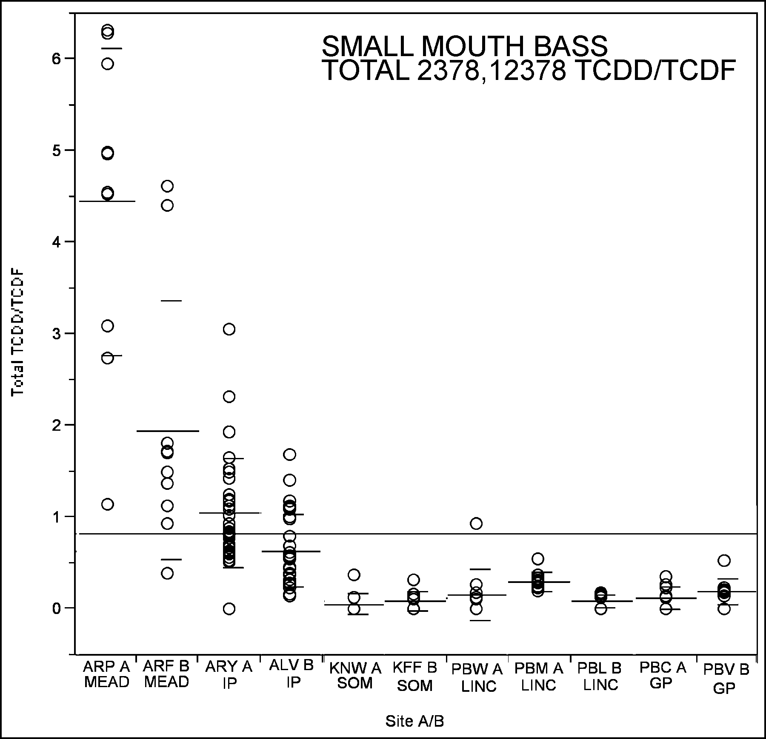

Figure 2. Small Mouth Bass Data Distribution/Comparison Total Lipid Normalized TCDD/TCDF
*Total TCDD/TCDF defined as sum of 2,3,7,8-TCDF. 1,2,3,7,8-PeCDF, 2,3,7,8-TCDD and 1,2,3,7,8-PeCDD
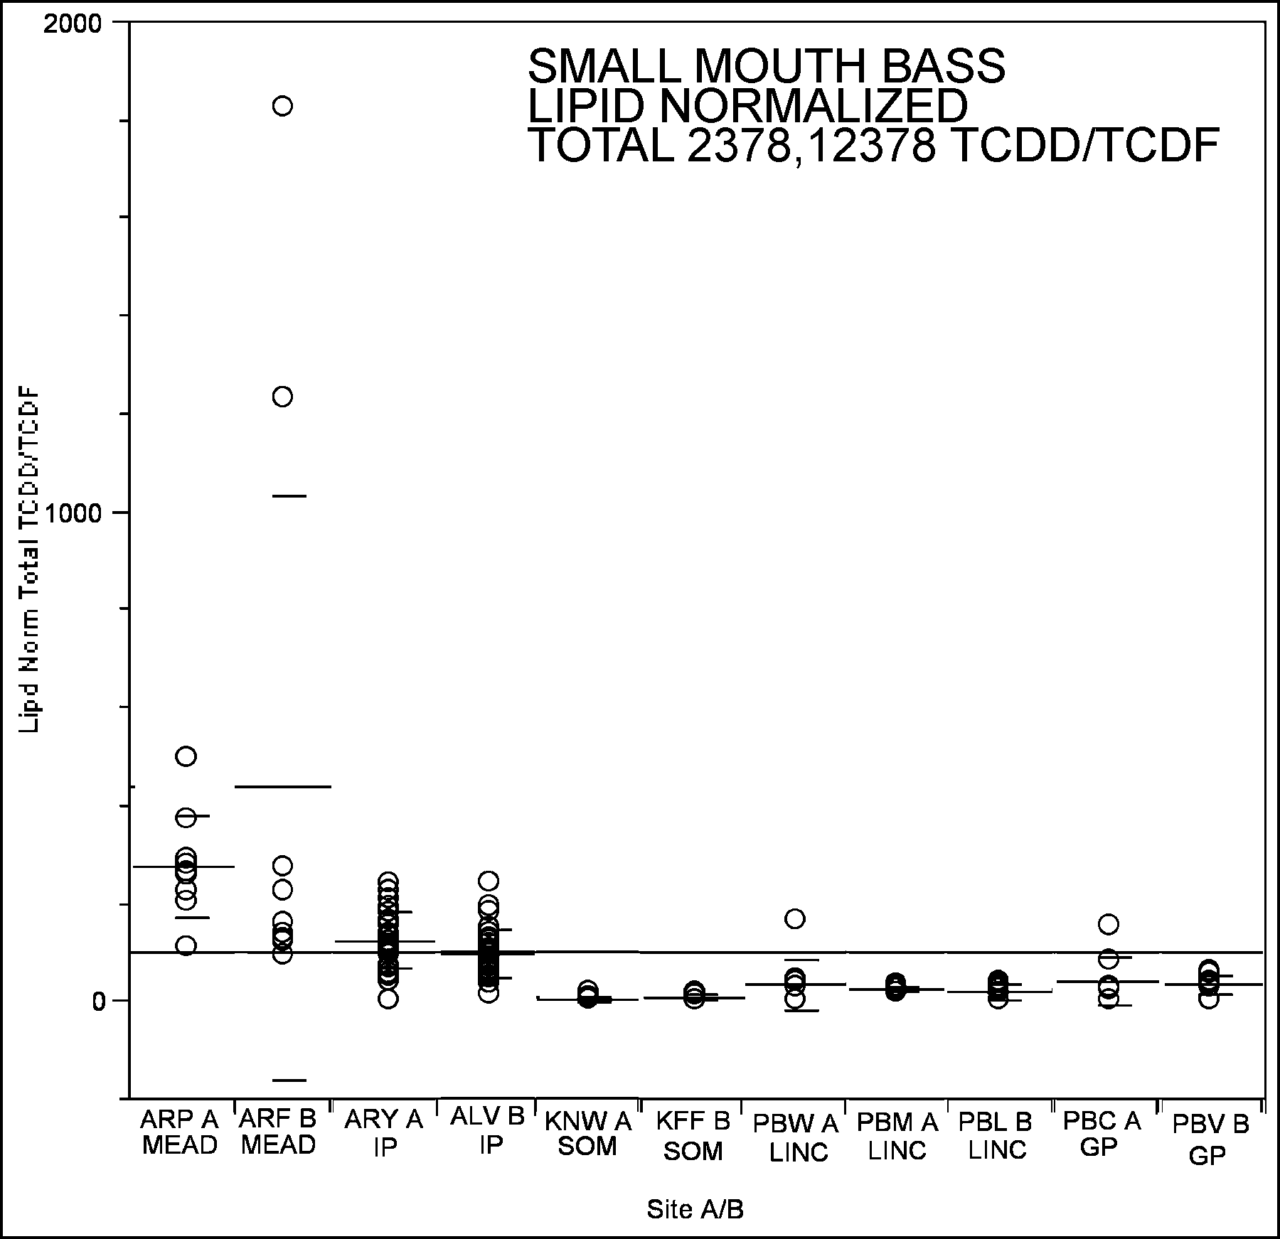
Large horizontal lines are means; small horizontal lines are standard deviations. Single line through all is the mean of all data.

Figure 3. Small Mouth Bass Data Distribution/Comparison TEQ (ND = 0)
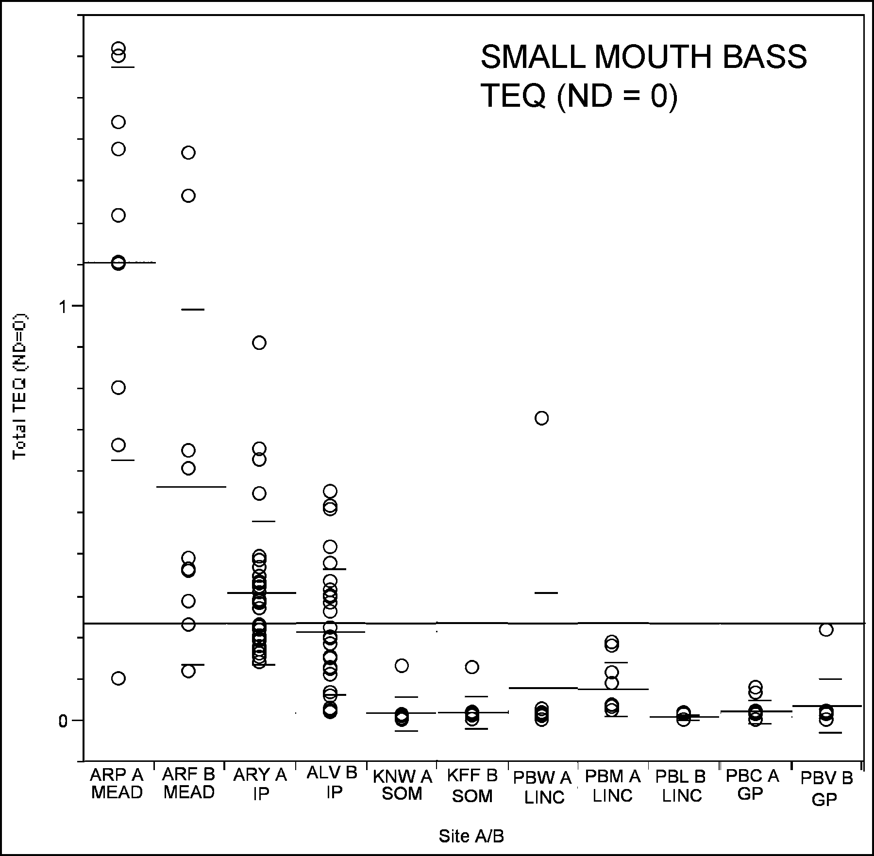
Large horizontal lines are means; small horizontal lines are standard deviations. Single line through all is the mean of all data.

Figure 4. Small Mouth Bass Data Distribution/Comparison Percent Lipid
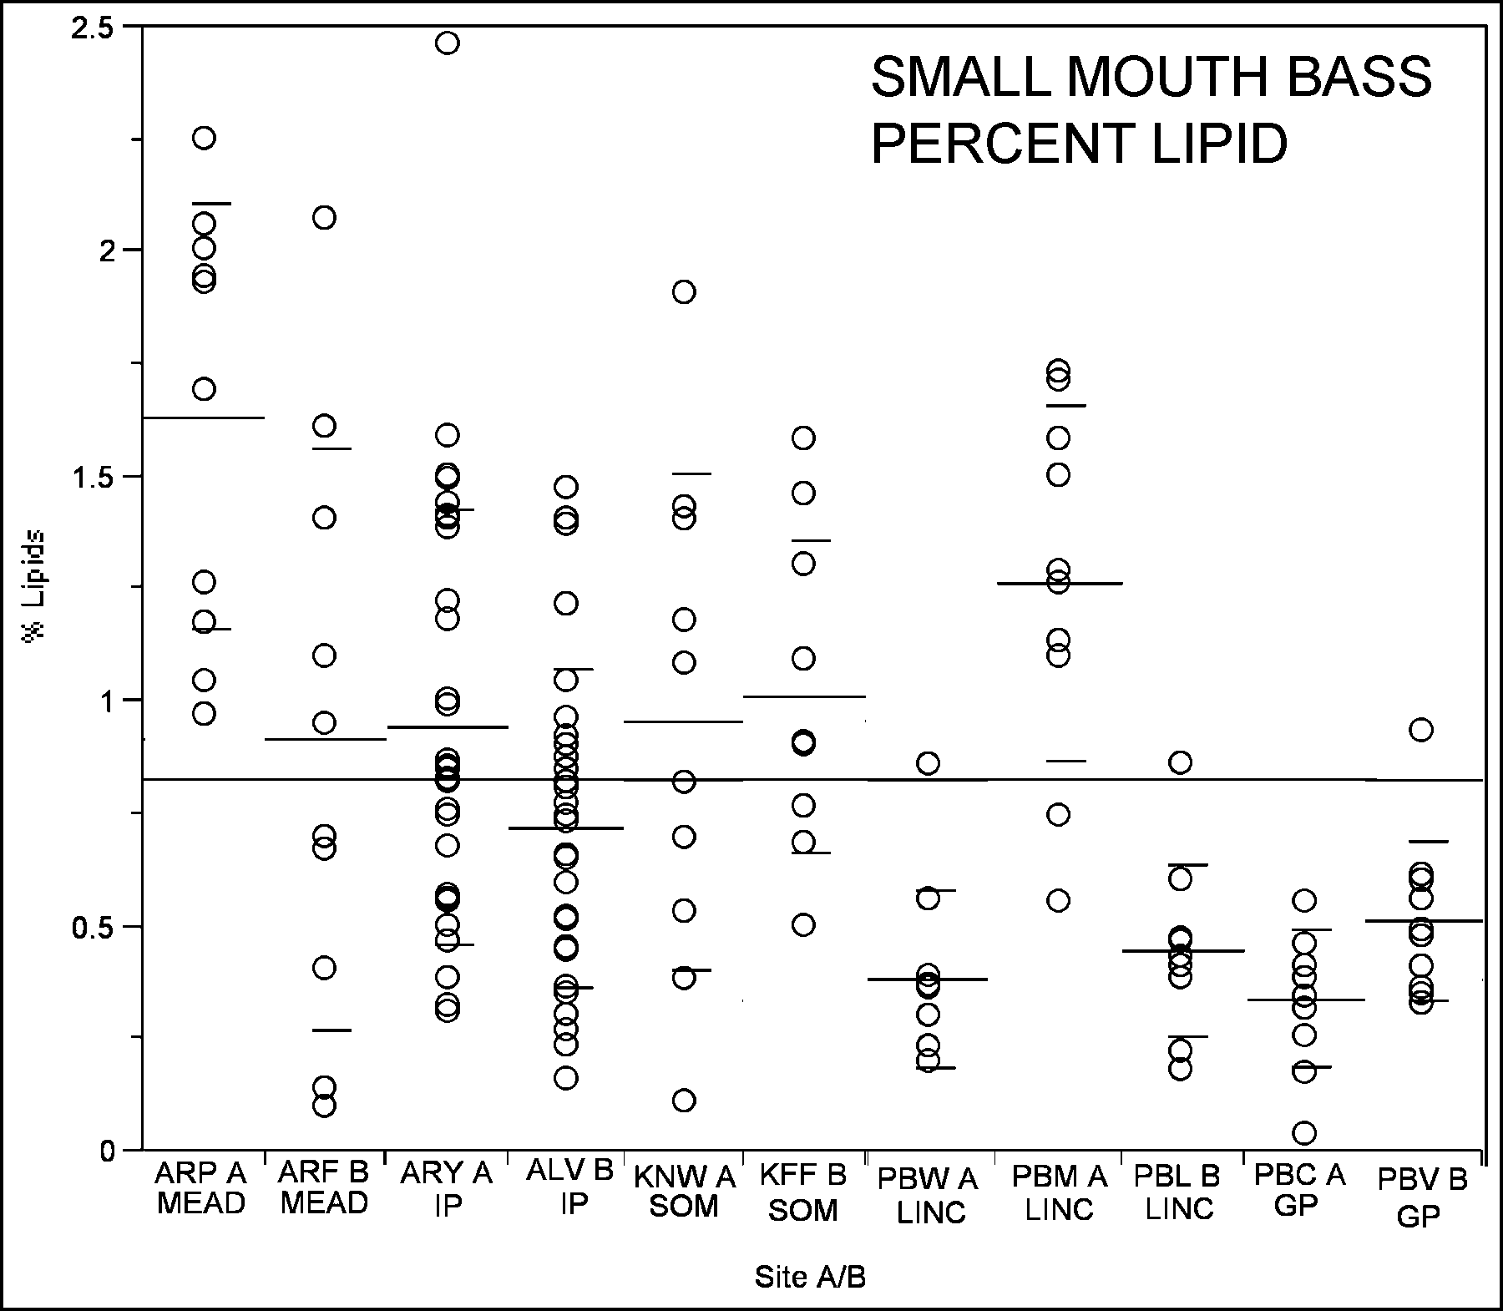
Large horizontal lines are means; small horizontal lines are standard deviations. Single line through all is the mean of all data.

Figure 5. White Sucker Data Distribution/Comparison Total TCDD/TCDF
*Total TCDD/TCDF defined as sum of 2,3,7,8-TCDF. 1,2,3,7,8-PeCDF, 2,3,7,8-TCDD and 1,2,3,7,8-PeCDD
Large horizontal lines are means; small horizontal lines are standard deviations. Single line through all is the mean of all data.
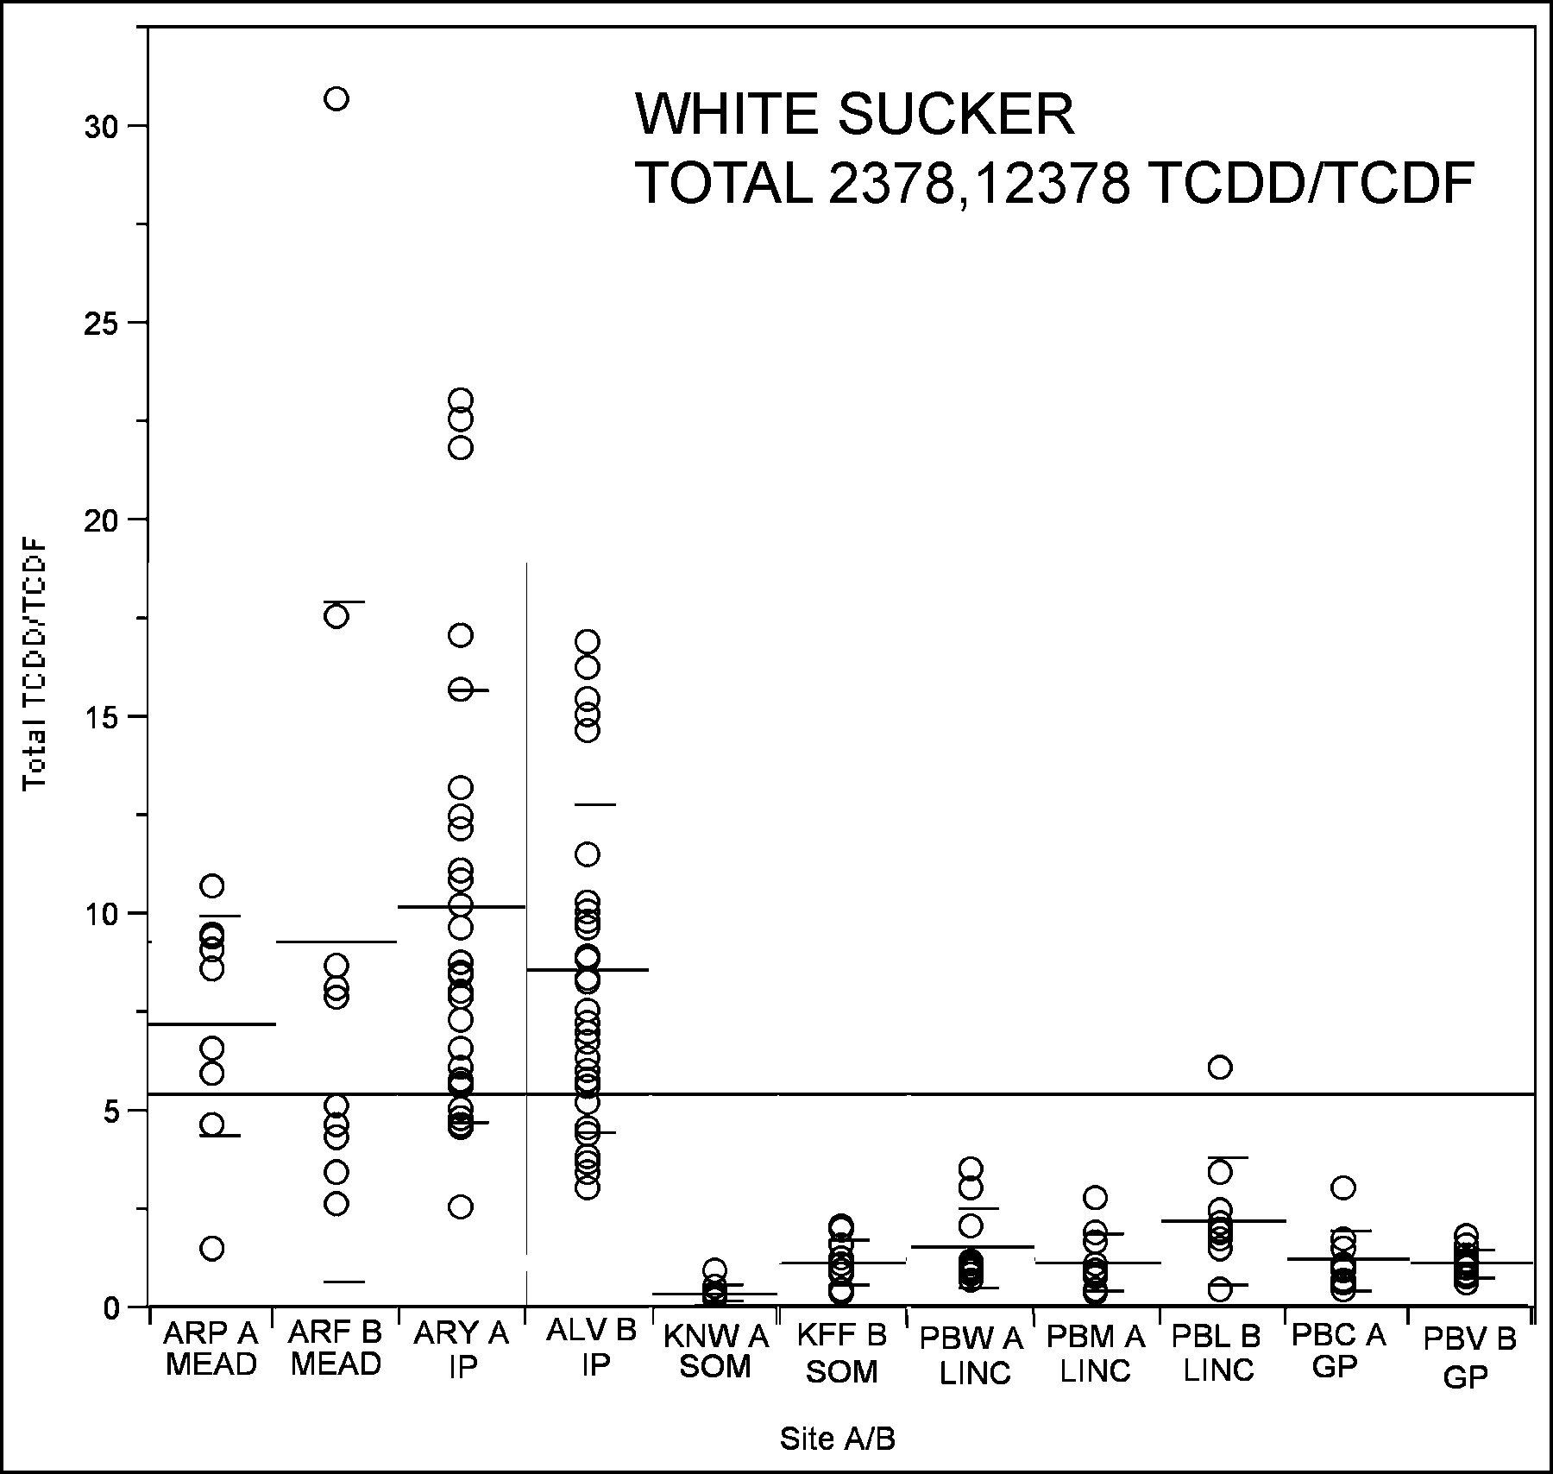

Figure 6. White Sucker Data Distribution/Comparison Total Lipid Normalized TCDD/TCDF
*Total TCDD/TCDF defined as sum of 2,3,7,8-TCDF. 1,2,3,7,8-PeCDF, 2,3,7,8-TCDD and 1,2,3,7,8-PeCDD
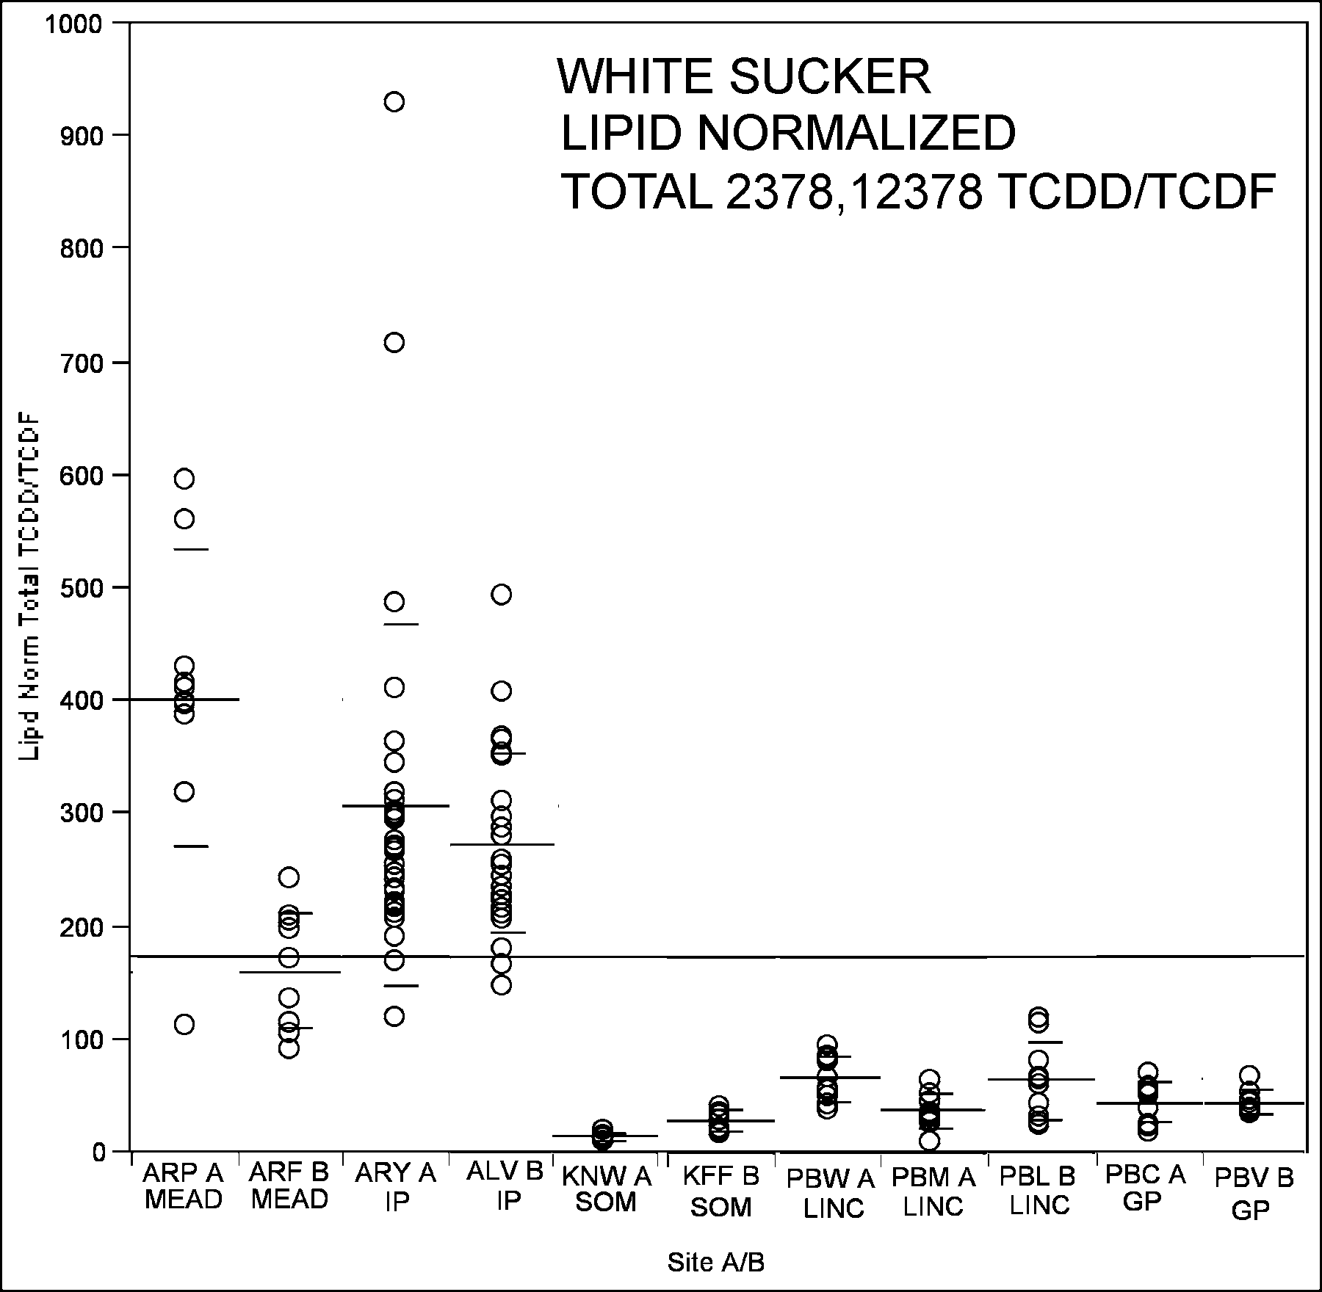
Large horizontal lines are means; small horizontal lines are standard deviations. Single line through all is the mean of all data.

Figure 7. White Sucker Data Distribution/Comparison TEQ (ND = 0)
Large horizontal lines are means; small horizontal lines are standard deviations. Single line through all is the mean of all data.
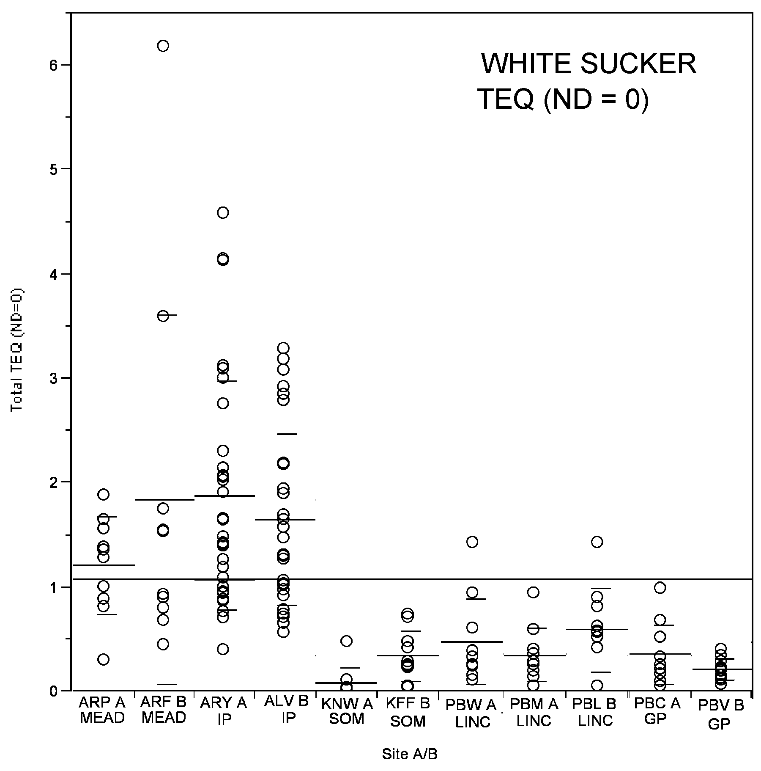

Figure 8. White Sucker Data Distribution/Comparison Percent Lipid
Large horizontal lines are means; small horizontal lines are standard deviations. Single line through all is the mean of all data.

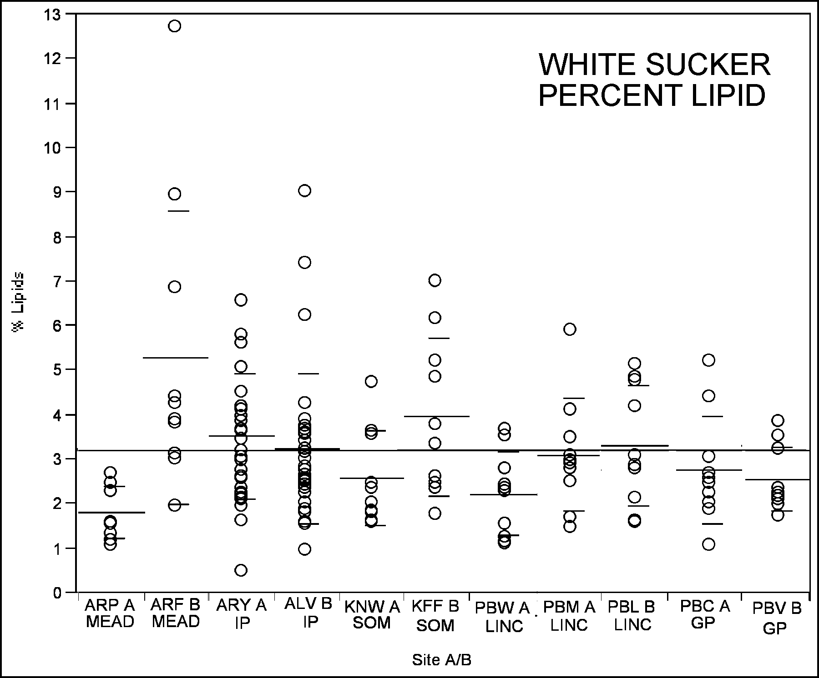

Figure 9. Comparison of total percent lipid values for White Suckers and Small Mouth Bass.

One way Analysis of % Lipids By species

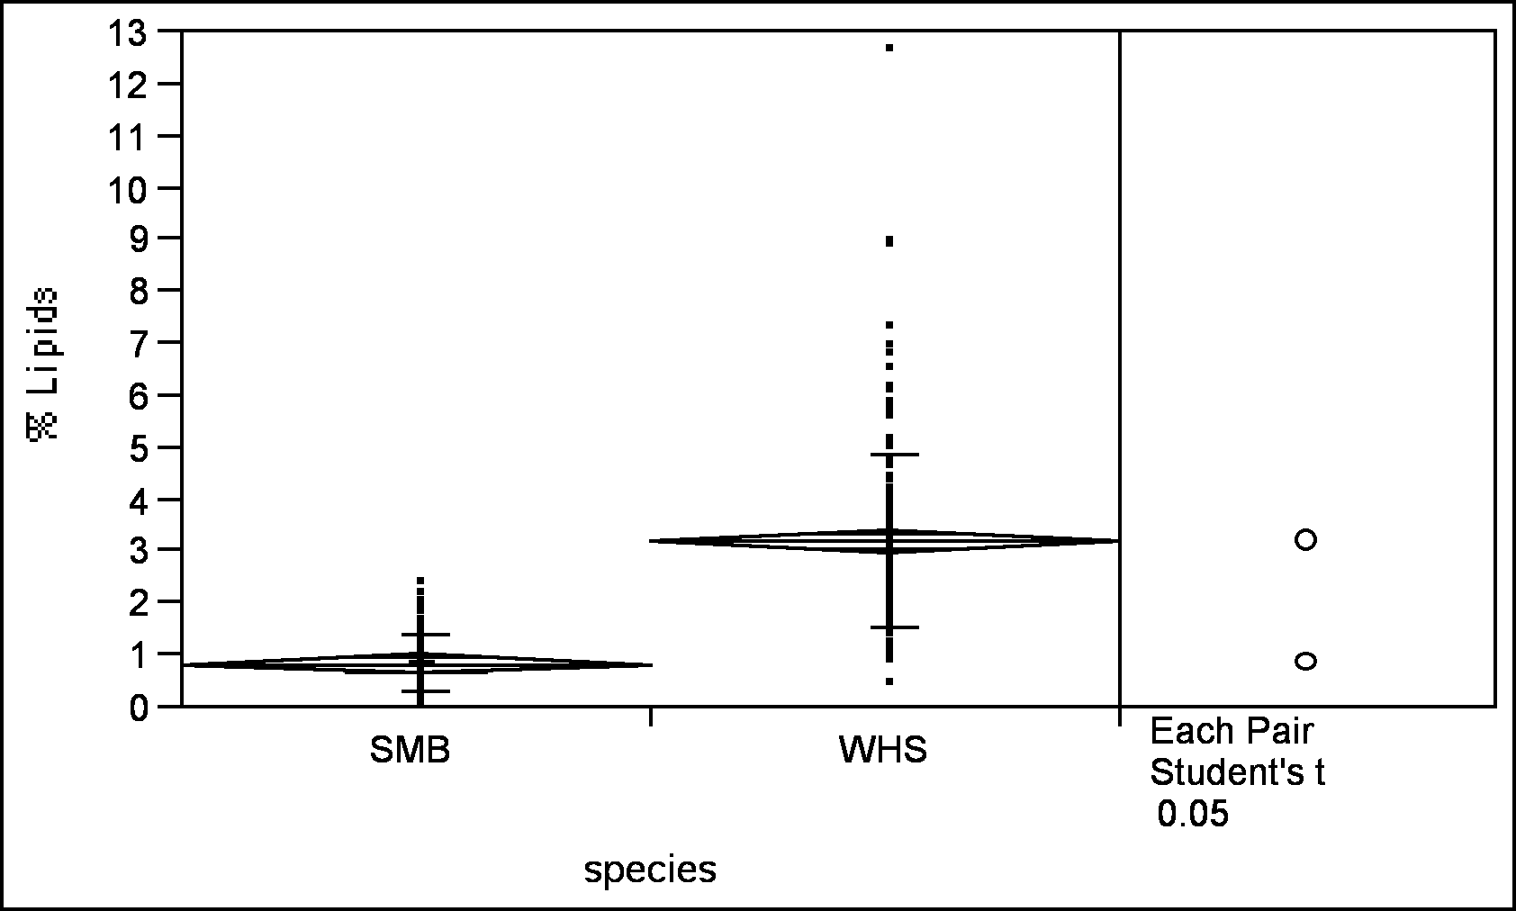

Means and Std Deviations
Level | Number | Mean | Std Dev | Std Err Mean | Lower 95% | Upper 95%
SMB | 150 | 0.82739 | 0.51242 | 0.04184 | 0.7447 | 0.9101
WHS | 150 | 3.17707 | 1.69389 | 0.13831 | 2.9038 | 3.4504
Means Comparisons
Dif=Mean[i]-Mean[j] | WHS | SMB
WHS | 0 | 2.3497
SMB | -2.3497 | 0.0000
Alpha=0.05
Comparisons for each pair using Student's t
t
1.96796

Abs(Dif)-LStandard Deviation | WHS | SMB
WHS | -0.2844 | 2.0653
SMB | 2.0653 | -0.2844

Positive values show pairs of means that are significantly different.

Appendix 2

Analysis of 2003 Mussel Data

Kennebec River 2003 Mussel Sampling Sites
(from Applied Biomonitoring January 13, 2003 Final Draft report)

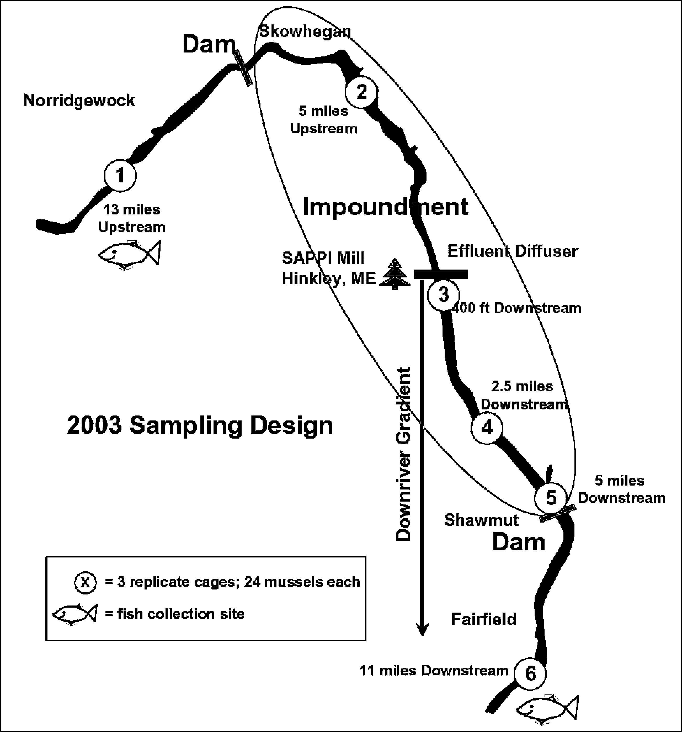

Comparison of 2003 Mussel DMP Data

Properties of 2003 Mussel Data Kennebec River Study

DEP ID | 2,3,7,8-  TCDF | 2,3,7,8- TCDD | Total TCDD/TCDF | Site mean | Standard Deviation | Standard Deviation as % of mean | % of DL* | 1234678 HpCDD | OCDD
KRMS0102 | 0 | 0 | 0 | 0.1 | 0.1 | 87 | 0 | 0.552 | 2.83
KRMS0110 | 0.145 | 0 | 0.145 |  |  |  | 73 | 0.707 | 3.64
KRMS0113 | 0.127 | 0 | 0.127 |  |  |  | 64 | 0.55 | 2.76
KRMS0217 | 0.124 | 0.676 | 0.8 | 0.6 | 0.4 | 66 | 400 | 1.22 | 6.58
KRMS0206 | 0.122 | 0.701 | 0.823 |  |  |  | 412 | 0.984 | 5.65
KRMS0219 | 0.143 | 0 | 0.143 |  |  |  | 72 | 0.562 | 2.8
KRMS0305 | 0 | 0 | 0 | 0.0 | 0.1 | 173 | 0 | 0.557 | 4
KRMS0321 | 0.115 | 0 | 0.115 |  |  |  | 58 | 0.578 | 4.69
KRMS0307 | 0 | 0 | 0 |  |  |  | 0 | 0.805 | 4.69
KRMS0411 | 0.129 | 0 | 0.129 | 0.1 | 0.1 | 87 | 65 | 0.73 | 5.21
KRMS0416 | 0 | 0 | 0 |  |  |  | 0 | 0.559 | 3.98
KRMS0415 | 0.117 | 0 | 0.117 |  |  |  | 59 | 0.6 | 4.27
KRMS0501 | 0.142 | 0 | 0.142 | 0.1 | 0.1 | 87 | 71 | 0.603 | 4.04
KRMS0518 | 0.128 | 0 | 0.128 |  |  |  | 64 | 0.618 | 3.65
KRMS0509 | 0 | 0 | 0 |  |  |  | 0 | 0.504 | 3.48
KRMS0608 | 0.117 | 0 | 0.117 | 0.1 | 0.0 | 9 | 59 | 0.801 | 4.25
KRMS0604 | 0.135 | 0 | 0.135 |  |  |  | 68 | 0 | 5.86
KRMS0614 | 0.14 | 0 | 0.14 |  |  |  | 70 | 0.862 | 6.09

DL is taken as 0.2, the sum of the DL for each analyte

Oneway Analysis of SUM 2378 TCDD and TCDF By SITE for 2003 Mussel program

Means Comparisons
Dif=Mean[i]-Mean[j] | 02A | 06B | 01A | 05B | 04B | 03B
02A | 0.00000 | 0.42467 | 0.44800 | 0.44867 | 0.45667 | 0.48367
06B | -0.42467 | 0.00000 | 0.02333 | 0.02400 | 0.03200 | 0.05900
01A | -0.44800 | -0.02333 | 0.00000 | 0.00067 | 0.00867 | 0.03567
05B | -0.44867 | -0.02400 | -0.00067 | 0.00000 | 0.00800 | 0.03500
04B | -0.45667 | -0.03200 | -0.00867 | -0.00800 | 0.00000 | 0.02700
03B | -0.48367 | -0.05900 | -0.03567 | -0.03500 | -0.02700 | 0.00000
Alpha=0.05 Comparisons for each pair using Student's t
t
2.17881

Abs(Dif)-LStandard Deviation | 02A | 06B | 01A | 05B | 04B | 03B
02A | -0.26785 | 0.15681 | 0.18015 | 0.18081 | 0.18881 | 0.21581
06B | 0.15681 | -0.26785 | -0.24452 | -0.24385 | -0.23585 | -0.20885
01A | 0.18015 | -0.24452 | -0.26785 | -0.26719 | -0.25919 | -0.23219
05B | 0.18081 | -0.24385 | -0.26719 | -0.26785 | -0.25985 | -0.23285
04B | 0.18881 | -0.23585 | -0.25919 | -0.25985 | -0.26785 | -0.24085
03B | 0.21581 | -0.20885 | -0.23219 | -0.23285 | -0.24085 | -0.26785
Positive values show pairs of means that are significantly different.

APPENDIX 3

DIOXIN CONGENER DISTRIBUTIONS FOR VARIOUS SOURCES

(Source: http://cfpub.epa.gov/ncea/cfm/part1and2.cfm?ActType=default)

[EPA Draft Final Report (Dioxin Reassessment) 9/00
Chart Source Chapter 8, page 87 link: http://epa.gov/ncea/pdfs/dioxin/part1/volume2/chap8.pdf

The distribution of dioxin congeners is diagnostic of the source. In particular, pulp and paper sources are dominated by the 2,3,7,8-TCDD.and 2,3,7,8-TCDF compounds (see below). This is what I noted early on. This is a TEQ graph and not a mass graph. A more correct statement might be that: Assuming dioxin distribution conclusions are based on a more defining methodology than fish tissue data, pulp & paper mills are dominated on a TEQ basis by 2378-PCDF congeners. Mills with their large boilers can indeed be very large discharges of OCDD that can find it’s way into the rivers via air deposition into the large wastewater lagoon areas and then the effluent as well as by direct air deposition. To increase the discrimination of pulp and paper sources in analyzing the 2003 chemistry data, the concentrations of the following were considered in making comparisons: 2,3,7,8-TCDF. 1,2,3,7,8-PeCDF, 2,3,7,8-TCDD and 1,2,3,7,8-PeCDD. Octachloro-dioxins and furans, associated with combustion sources, were not included in the data analysis.
The congener profiles are presented as the fractional distributions of total CDD/CDF for the example sources indicated.

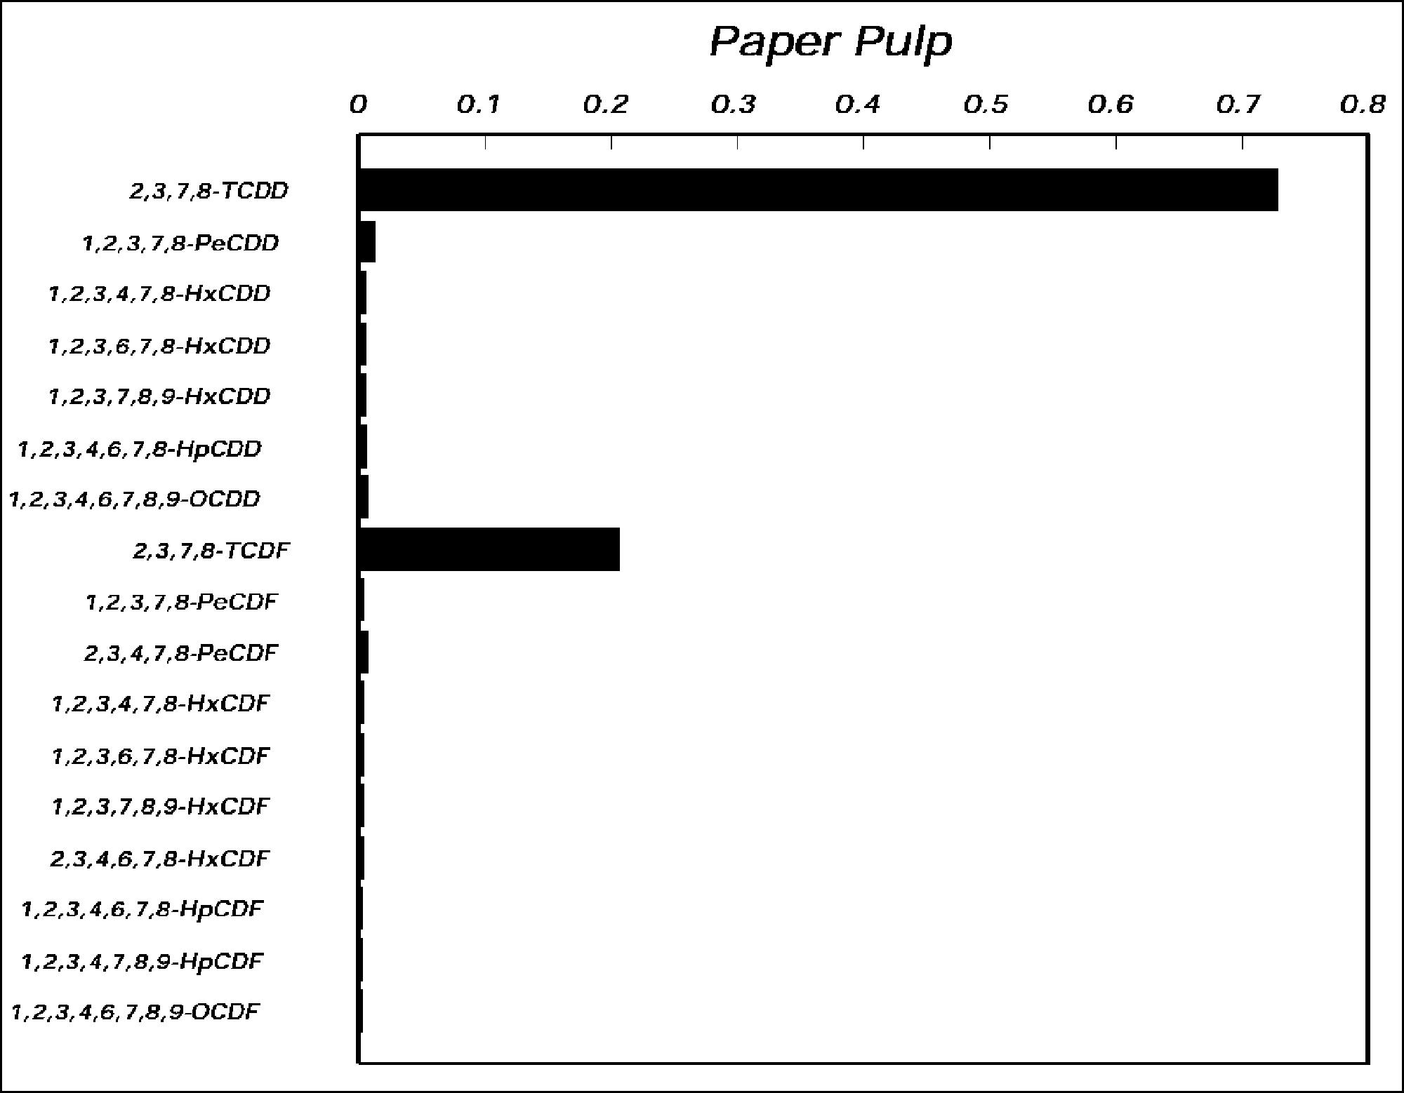
By TEQ [See Salazar email [“Dioxin Conger Distribution”-also on FOMB web site]with other chart for break down by mass or go to epa link 8-87]

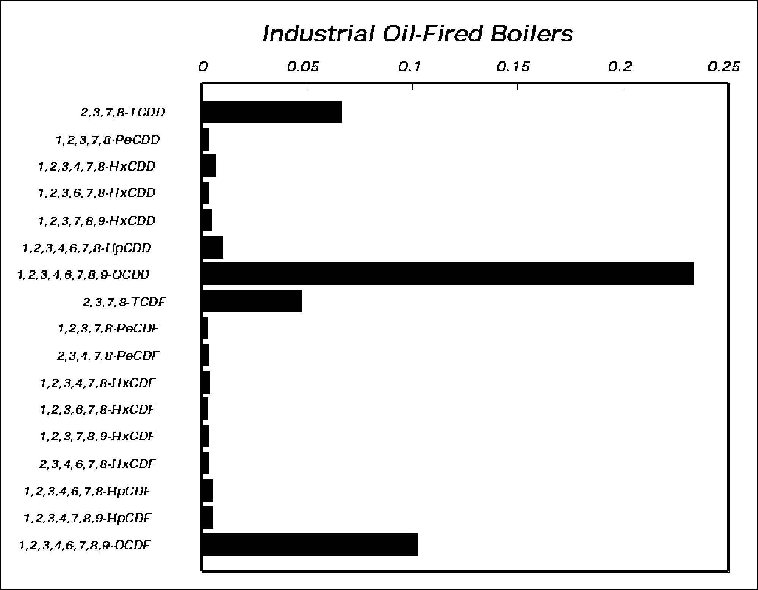

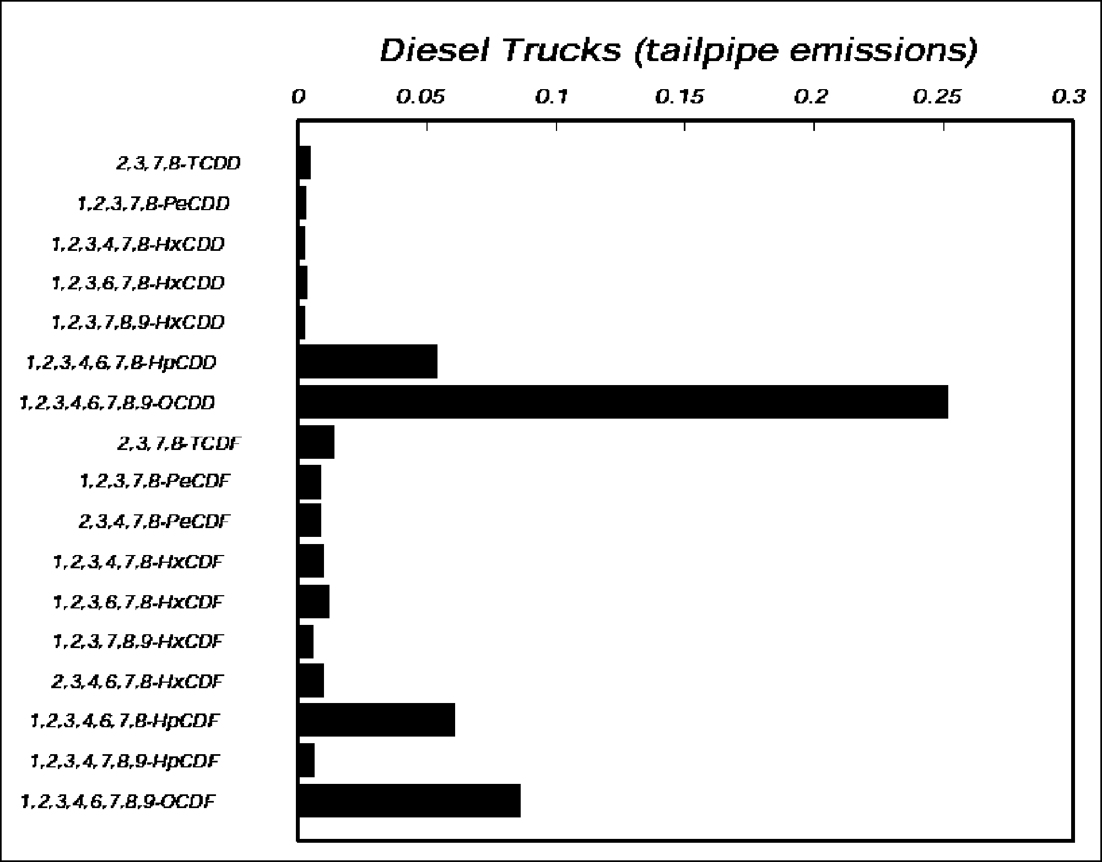
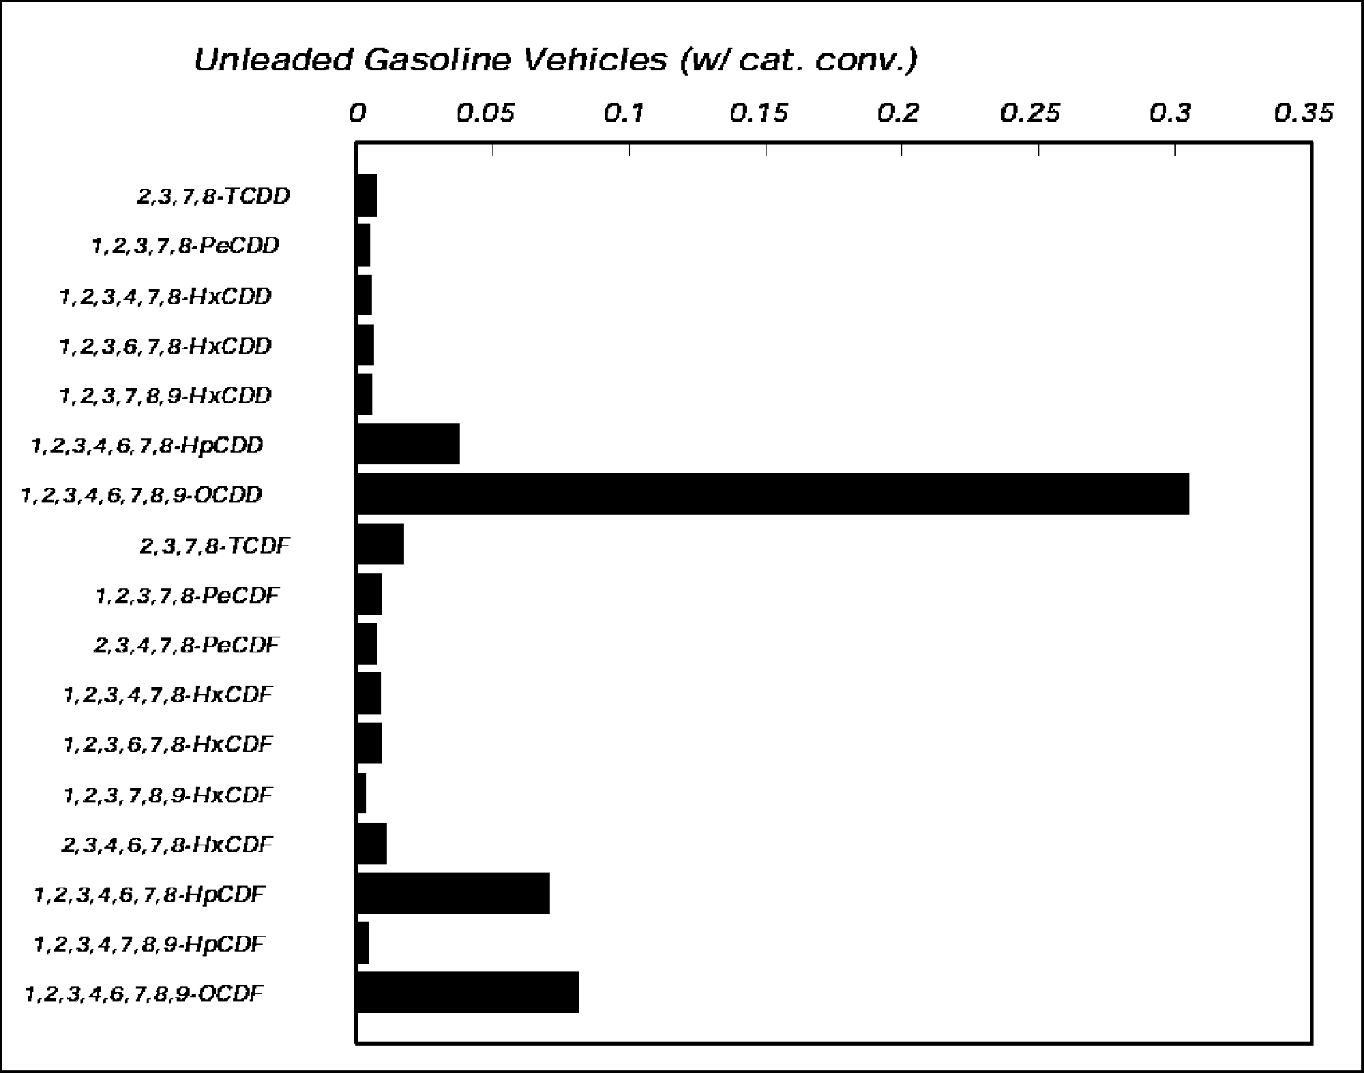

Appendix 4. Analysis of Dioxin Lipid Data
Objective
Lipid data from SMB and WS was analyzed to determine if values seemed reasonable given the species and size ranges collected for dioxin analysis.
Methods
Percent (wet wt) lipid data for SMB and WS collected at sites in the Androscoggin, Kennebec, and Penobscot rivers was obtain from Appendix 2A of the 2001 report. Total lengths of sampled fish were obtained from Appendix 7. Note that there were some fish of both species where lipid data was available but the corresponding lengths (and weights) were missing. Also there were a few fish where the lengths were available but lipid data was missing. Lengths were used instead of weights because there were more data points for lengths than weights.
Percent lipid was plotted as a function of total length (mm) and 5 figures were generated. In Fig. 1 the percent lipid vs length is shown for all SMB from all sites where there was both lipid and corresponding length data. The difference in Fig. 2 vs Fig. 1 is that Fig. 2 does not include the juvenile SMB (designated as SSMB) in the Appendix. In Fig. 3, lipid and size are plotted separately for each of the three rivers. In Fig. 4 lipid-size is plotted for all WS together and in Fig. 5 lipid and size are plotted separately for each river.
Results/Discussion
(1) In Fig. 1 the lipid levels of juvenile SMB (lengths about 150mm) are 2-3 times higher than the larger adult SMB (lengths 300-400) which is not the normal relationship between fish size and lipid levels.
(2) In Fig. 2 showing all SMB excluding juveniles there is no lipid-size trend which is again not the expected or normal situation
(3) In Fig. 3 there is the expected size-lipid relationship for SMB from Penobscot but the other 2 river have reversed trends which is definitely not normal. In addition lipid values for the Androscoggin are highly variable within fish of similar size.
(4) As in Fig. 2 with SMB, for all WS there is no alloiometric relationship with lipid. This trend is entirely unexpected also because sucker species are normally much fattier fish than bass and the larger individuals (say above 450 mm) would certainly be expected to have higher lipids than those individuals less than this range.
(5) In Fig. 5 suckers from two rivers appear to have the expected size-lipid relationship but for these rivers (Kennebec & Penobscot) this relationship was not significantly different from zero (slope of line not different from zero).
Conclusions
The lipid data for both species, and particularly SMB, appears rather suspicious because of the following reasons:
1. In general, the lipid-size relationship is not consistent with the normal or expected alloiometric relationship with larger fish having proportionally higher fat levels
2. Lipid levels of juvenile SMB (fig. 1) are much higher than adults
3. For 2 out of the 3 rivers for SMB the relationship between lipid and size is negative
4. A comparison of the mean lipid levels of SMB and WS from this study compared to a few literature values for both species show, in general, that lipid levels are lower by approximately a factor of 2 (i.e., 2x lower) than literature. I realize that this may be a rather tenuous comparison because of differences in aquatic systems, nutrition, etc. but for SMB wet weight values ranged from 1-6 % (mean 2-3%) for juvenile and adults) while white sucker ranged between 2-6 (mean 3-4%).
If, in fact lipid values for SMB and WS, and particular SMB, are lower than the true levels, then what does this mean in terms of the lipid-normalized dioxin calculations? If, in fact, lipid levels reported in Appendix 2A are a factor of 2 (or even more) lower than the real values does this mean that the reported (calculated) dioxin values may be too high.
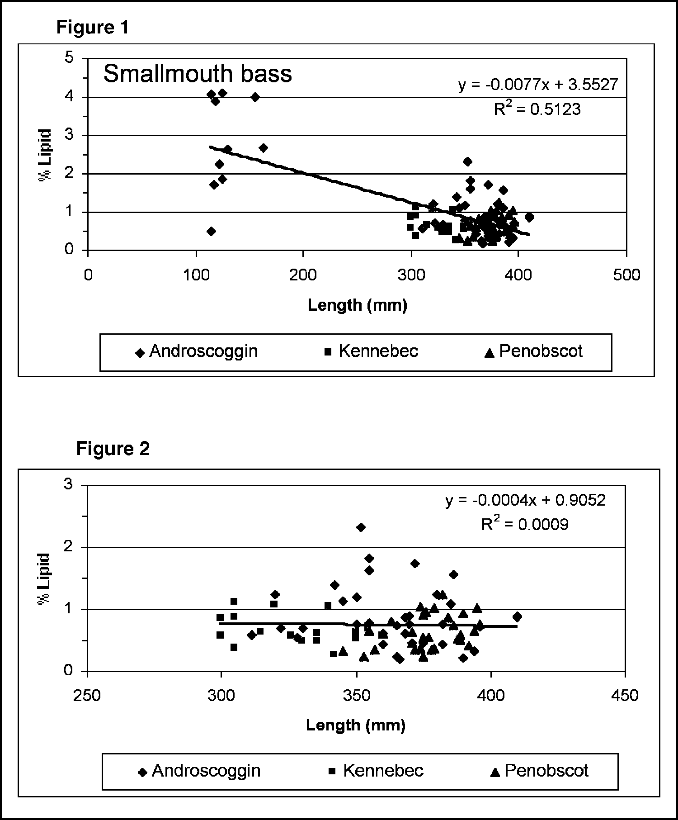
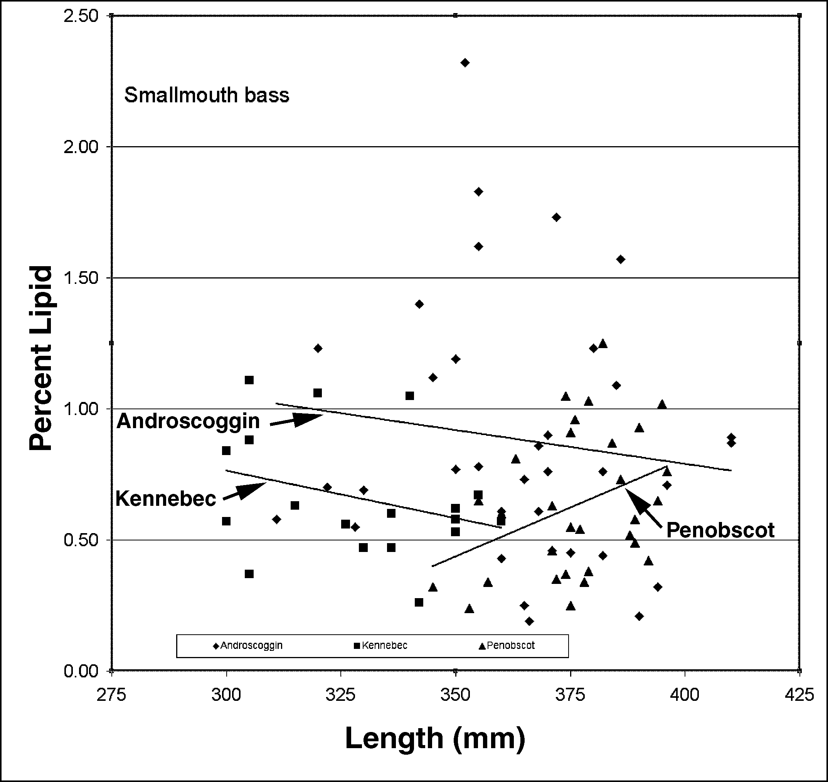
Figure 3.

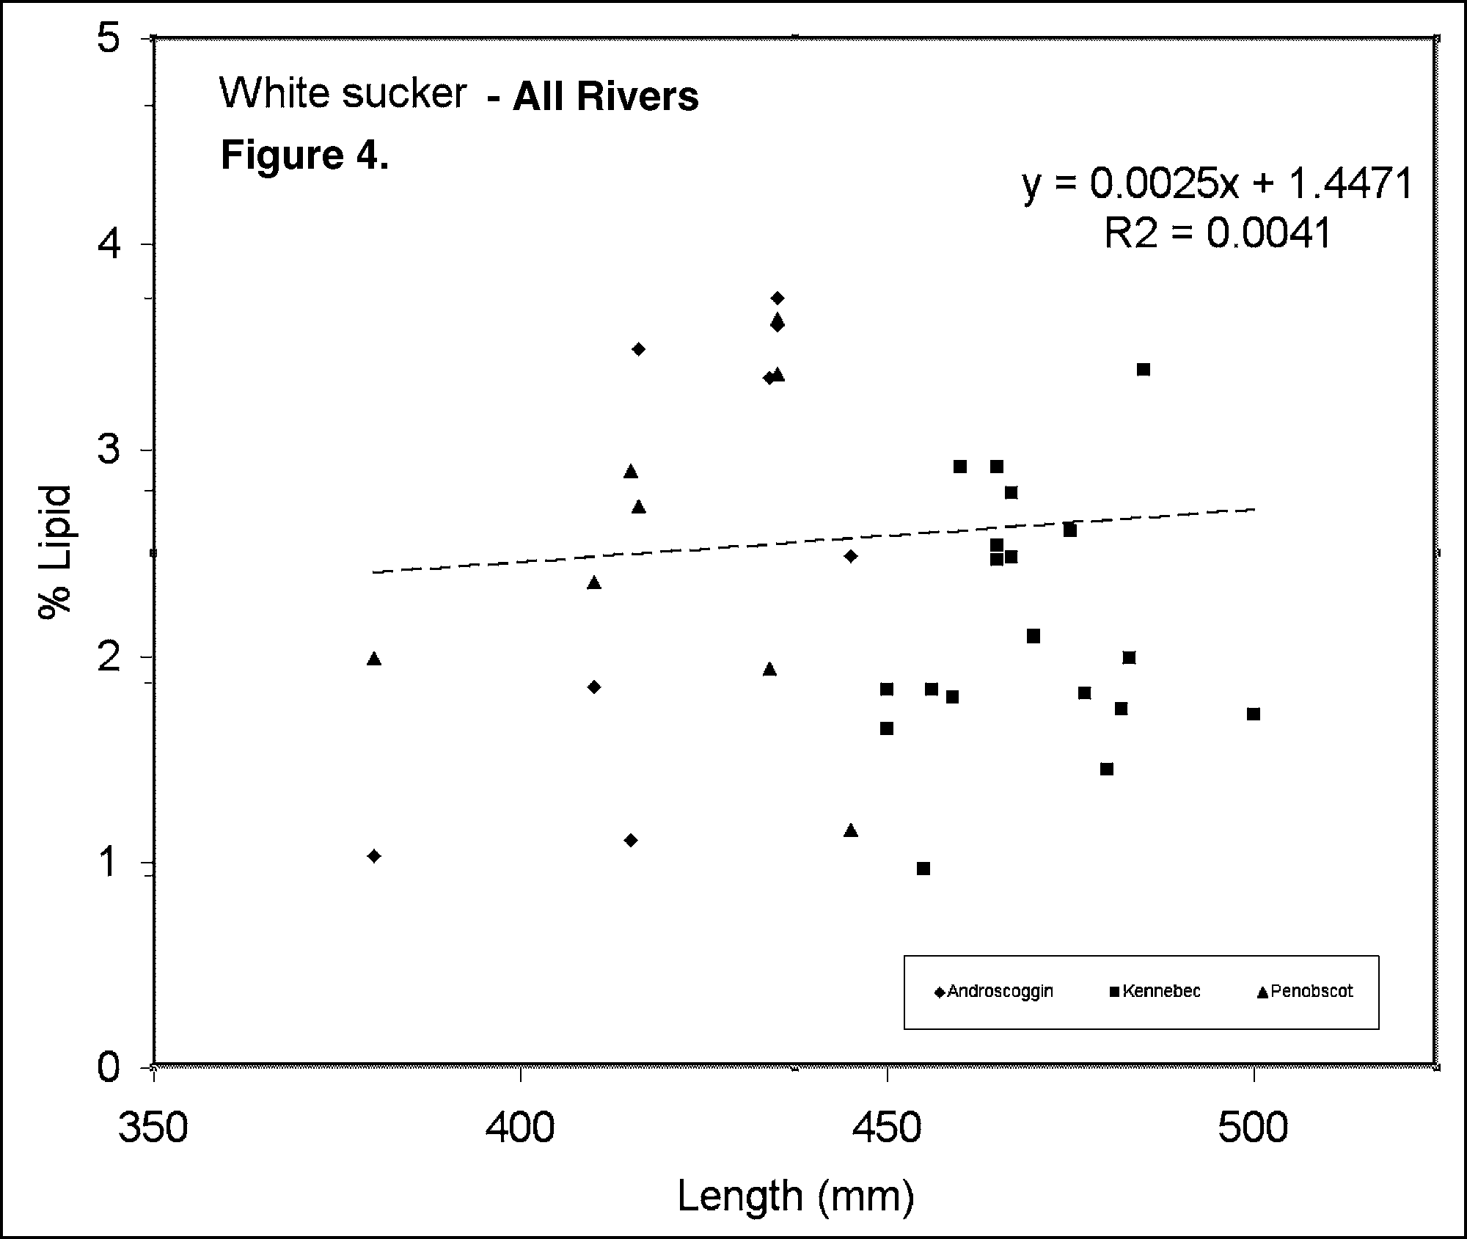
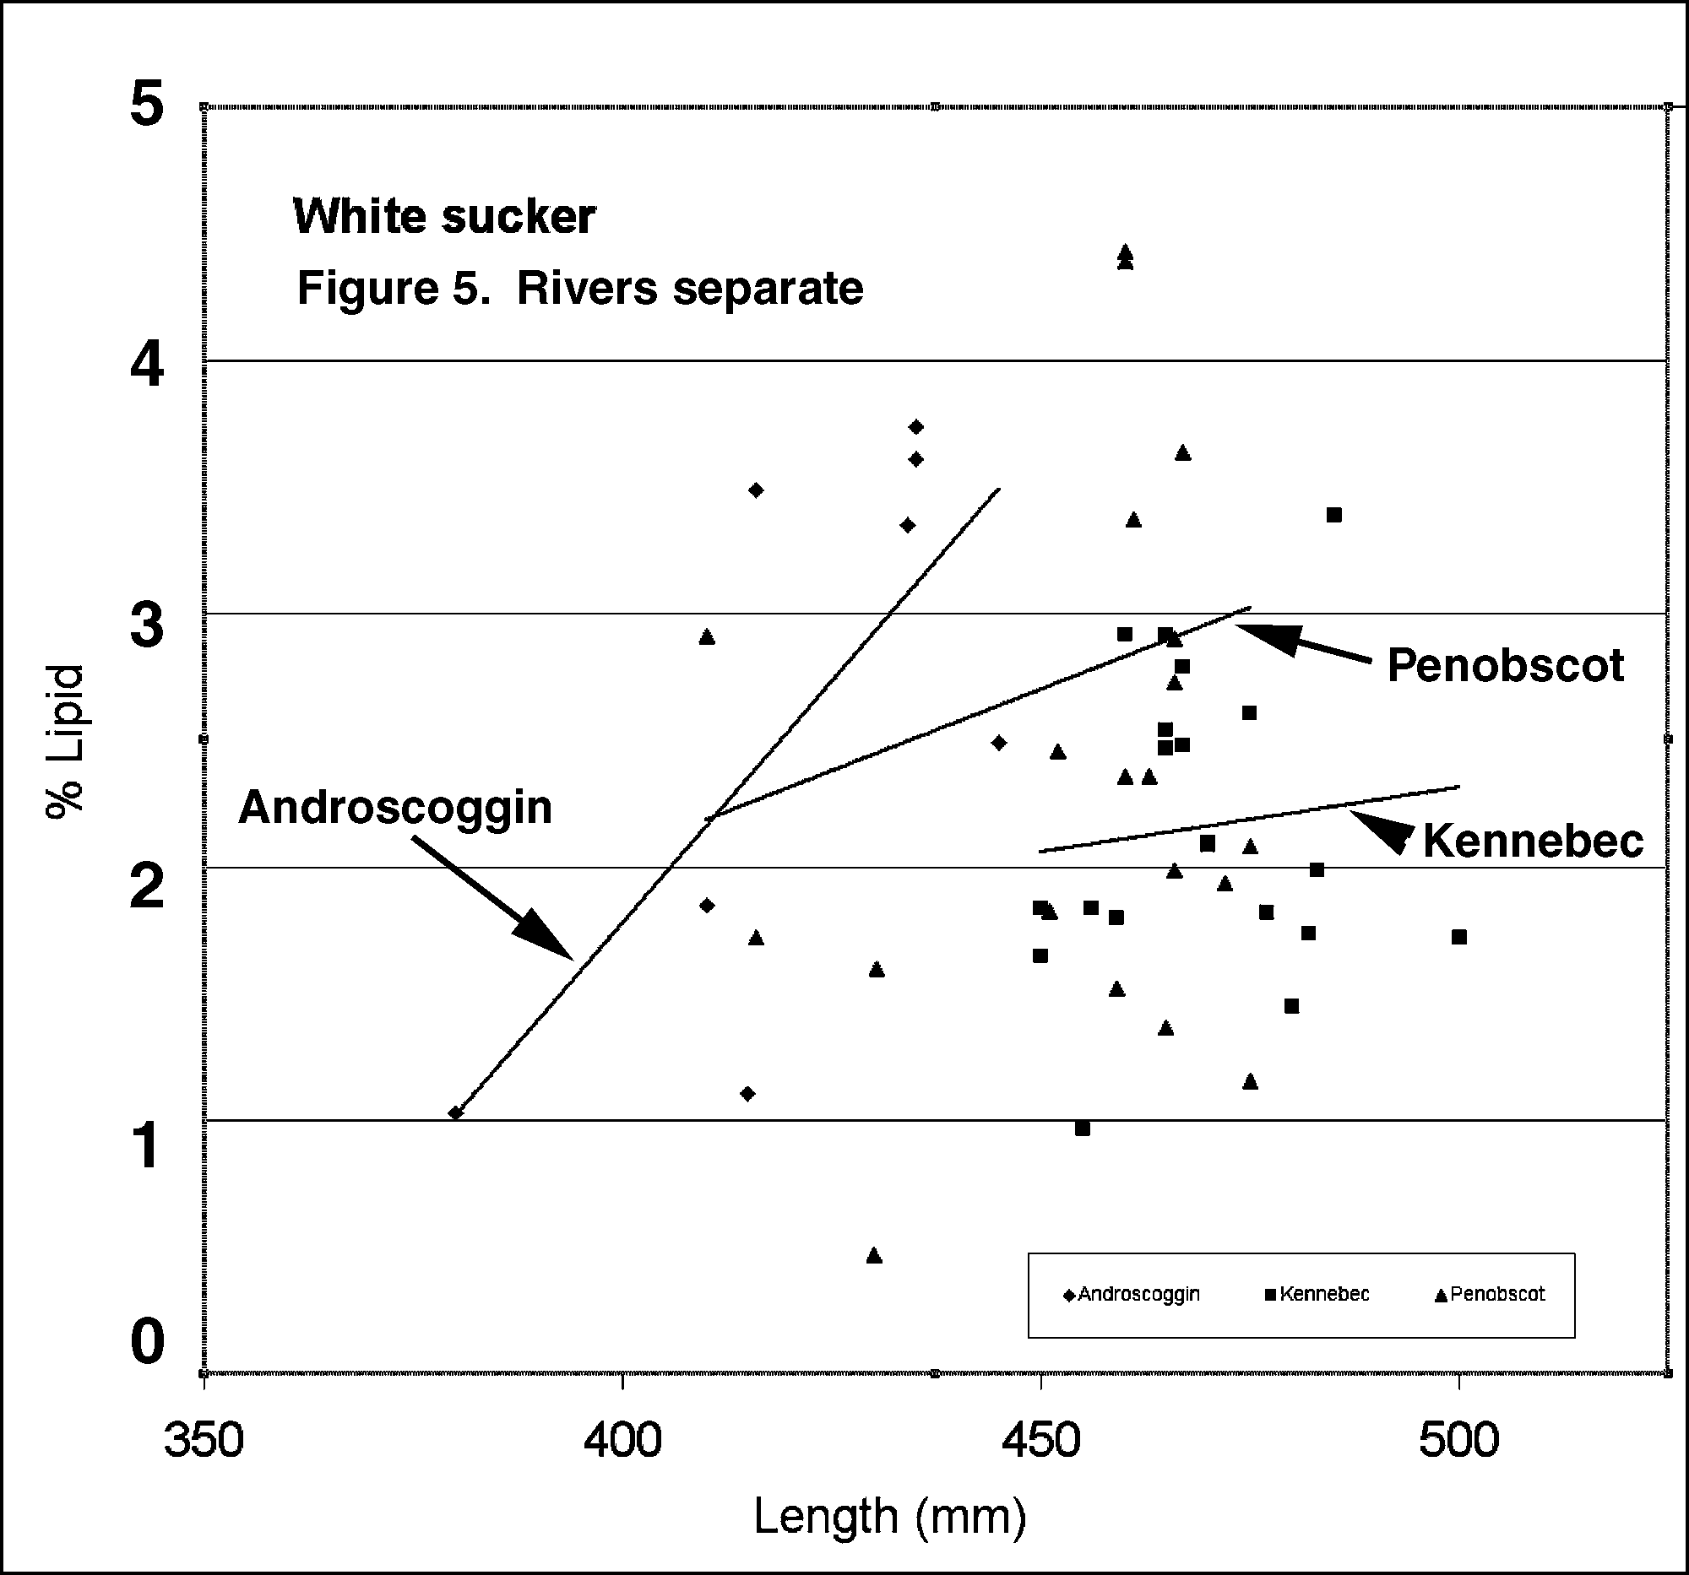
Appendix 5: Statistical Calculations

- Representative power calculations.

This table presents sample sizes (on left margin), Type I error probs. (alpha on top margin), and the Type II error probs. (body of table) that would result from trying to detect a 1ppt difference between the A/B sites. The SD was derived from the 2003 SMB data collected from the A/B sites at the Mead mill on the Androscoggin River.

 | SMB |  | Total D
difference | 1.00
SD | 2.19 |  |  | alpha
 |  | 0.25 | 0.2 | 0.15 | 0.1 | 0.05
 | 10 | 0.396 | 0.449 | 0.516 | 0.602 | 0.724
sample | 15 | 0.276 | 0.323 | 0.385 | 0.469 | 0.601
size | 20 | 0.192 | 0.231 | 0.284 | 0.360 | 0.489

The Type II error probability is the lower (or left-hand) tail probability from the non-central t distribution with non-centrality parameter:

t-critical value defined by alpha, and degrees of freedom =2*N-2. N is the sample size and  is the standard deviation obtained by pooling the A and B site SD’s.

- Calculation of Type I and Type II error probabilities.

  - Independent Applicability approach - (if at least 1 of 3 tests is statistically significant a mill is non-compliant)

A Type I error (or false positive) occurs when a compliant mill fails to “pass” all three tests. If each test is conducted at  =5%, a compliant mill will “pass” each 95% of the time. It will pass all three tests (.95)(.95)(.95) = .857 = 85.7% of the time. Thus the likelihood that a compliant mill does not “pass” all three tests is 1-.857 = .143 = 14.3%. This, 14.3%, is the Type I error probability. To lower the overall Type I error probability, the  for each test must be lowered (or, equivalently, the confidence must be raised). The appropriate confidence level can be obtained by solving this equation: (x)(x)(x)=.95. The resulting confidence level needs to be .983 or 98.3% and hence the individual  level will be 1.7%.

A Type II error (or false negative) occurs when a non-compliant mill “passes” all three tests. If each test has power of 95%, then the Type II error probability () for each test is 5% and the probability of a overall Type II error is (0.05)(0.05)(0.05) = 0.000125. To raise the overall Type II error rate each individual  must be raised. The appropriate  can be obtained by solving this equation: (x)(x)(x) = 0.05. The resulting individual  needs to be .368 or the individual power will be 63.2%.

2. POE approach - (if mill “fails” 2 or more of 3 tests the mill is non-compliant)

The reasoning is very similar to that given above. A false positive occurs when a compliant mill fails 2 or more of 3 tests. This probability is obtained using the binomial distribution with n=3, p=, and finding the probability of two or more “successes”. If the individual test  level is 5% then the probability of the Type I error is .00725. If, instead, the individual  level is 13.5% then the overall probability of a Type I error is 5%.

A false negative will occur when a non-compliant mill passes 2 or more of 3 tests. This probability is calculated the same way as the Type I error using the binomial distribution. Thus, with individual  levels at 5% the overall Type II error probability will again be .00725. By adjusting the  levels to 13.5% the overall Type II error probability will be 5%.

- Comparison of detectable MSDs for the IA and POE approaches.

In order to compare the IA and POE approaches, a method needs to be found that is not dependent upon the fact that the spread in TCDD/TCDF values varies from mill location to mill location. The usual formula for calculating sample size requires power, significance level, variance, and MSD. This is the formula:

If the MSD is expressed as a multiple of the SD, say k, then the above formula can be simplified. The result is:

This can then be rearranged to give an expression for k. The expression is:

This formula was used to calculate the percentages comparing the sensitivities of the different procedures.

October 1, 2003 letter from Andrew Fisk to DMP review panel members.

